Windows Autopilot
Zero-to-Advanced Master SOP and Operational Runbook
Plan | Register | Configure | Assign | Deploy | Secure | Monitor | Troubleshoot | Reset | Handover
Purpose
One practical reference for Endpoint Management engineers covering new box-pack device registration, hardware hash, Microsoft Entra groups, Windows Autopilot deployment profiles, Enrollment Status Page, user-driven and self-deploying scenarios, pre-provisioning, Intune policies, applications, OOBE validation, reporting, troubleshooting, lifecycle, governance, and interview knowledge.

Document field | Value
Owner | Endpoint Management / IT Operations
Platforms | Windows 10/11, Microsoft Intune, Microsoft Entra ID
Primary scenario | Corporate Windows Autopilot user-driven deployment
Related scenarios | Self-deploying, pre-provisioning, existing devices, device preparation overview
Version | 2.0 Master
Prepared date | 24 September 2026
Source material | Windows Autopilot.docx and Hardware Hash Complete SOP
Classification | Internal use

1. Fundamentals and Architecture

1.1 What Windows Autopilot does
Windows Autopilot uses a cloud-based device identity and assigned deployment settings to customize Windows out-of-box experience. It does not create the Windows image. The OEM image remains on the device, while Intune and Microsoft Entra ID provide enrollment, configuration, security policies, applications, and reporting.

1.2 Core objects
Object | Purpose | Common mistake
Hardware identity / registration | Associates a physical device with Autopilot service | Confusing registration with Intune enrollment
Group Tag | Metadata used for grouping and targeting | Tag typo prevents expected group membership
Microsoft Entra device group | Target for profile, ESP, apps, and policies | Mixing user and device targeting without design
Deployment profile | Controls OOBE behavior and join type | Profile not assigned before OOBE
Enrollment Status Page | Tracks device/user setup and can block use | Too many blocking apps
Intune managed device | Created after enrollment | Assuming imported device is already managed
Primary user | User association after enrollment | Incorrect ownership/user assignment
Configuration and compliance | Applies security and operational standards | Conflicting policies

1.3 End-to-end lifecycle
- Design and prerequisites
- Acquire device through OEM/reseller or collect hardware hash
- Register device and validate identity
- Apply Group Tag and dynamic/static group membership
- Create and assign deployment profile
- Create and assign Enrollment Status Page
- Assign required applications, scripts, security, compliance, and update policies
- Wait for Autopilot profile status Assigned
- Start clean OOBE and complete deployment
- Validate Intune, Entra, apps, encryption, compliance, recovery key, and asset record
- Support, reset, redeploy, transfer, or retire device

2. Prerequisites, Roles, Licensing, and Network

2.1 Readiness checklist
- Intune tenant and MDM authority configured.
- Microsoft Entra automatic enrollment configured for intended users.
- Supported Windows edition and version.
- Users licensed for required Microsoft cloud services.
- Authorized RBAC role for enrollment programs, apps, policies, and device management.
- Corporate network allows required Microsoft endpoints, certificate validation, DNS, and time synchronization.
- Device has working TPM and network adapter drivers for the intended scenario.
- Deployment groups, naming, Group Tags, profile ownership, and change control are documented.
- Pilot devices and pilot users are available.

2.2 Recommended RBAC separation
Responsibility | Example least-privilege approach
Register/import devices | Autopilot device management permissions
Profiles and ESP | Policy/Profile management permissions
Apps | Application management permissions
Device actions | Help Desk / device management permissions
Tenant and enrollment configuration | Intune administration with change approval

2.3 Network validation principles
- Use wired Ethernet where feasible for high-volume staging.
- Avoid captive portals during OOBE.
- Confirm proxy authentication does not require an interactive user before sign-in.
- Validate DNS, date/time, TLS inspection exceptions, and content delivery access.
- Test from the real office, home, and VPN scenarios used by employees.
Security and privacy
Hardware hashes and device identifiers are sensitive operational data. Store them only in approved IT locations, restrict access, and remove temporary USB copies after import and evidence retention.

3. Portal Navigation and Autopilot Areas
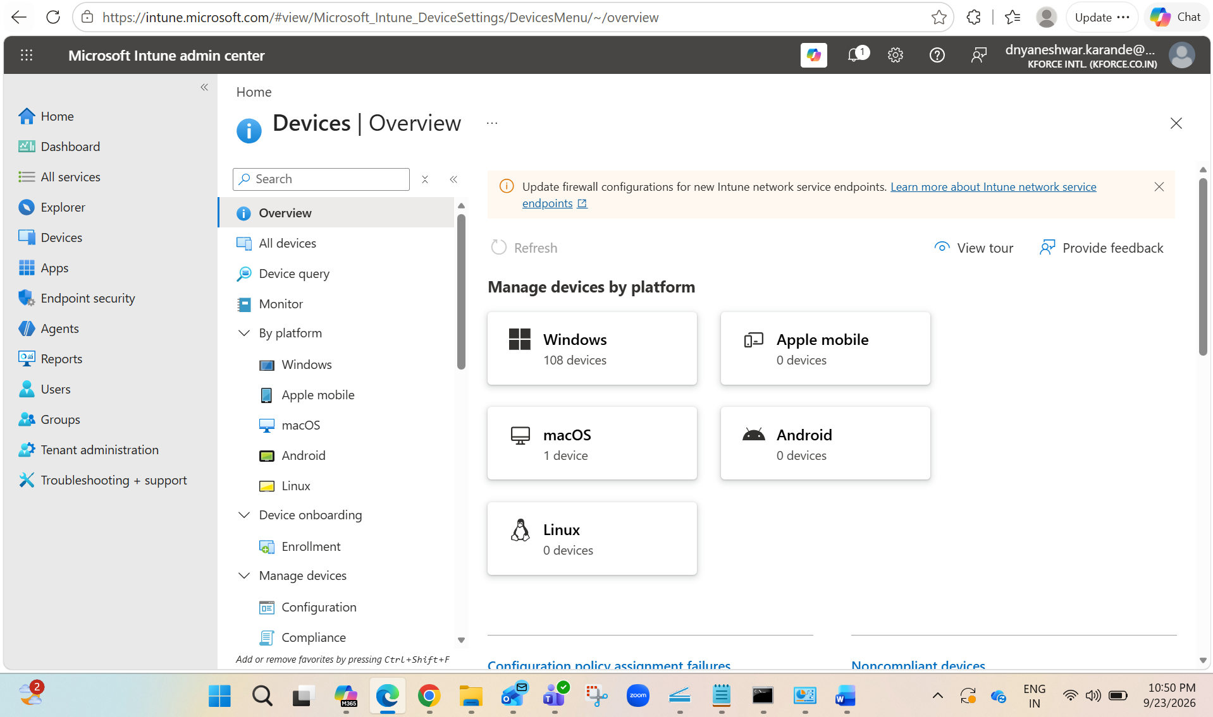
Figure 1. Intune Devices overview. Select Windows under managed devices.
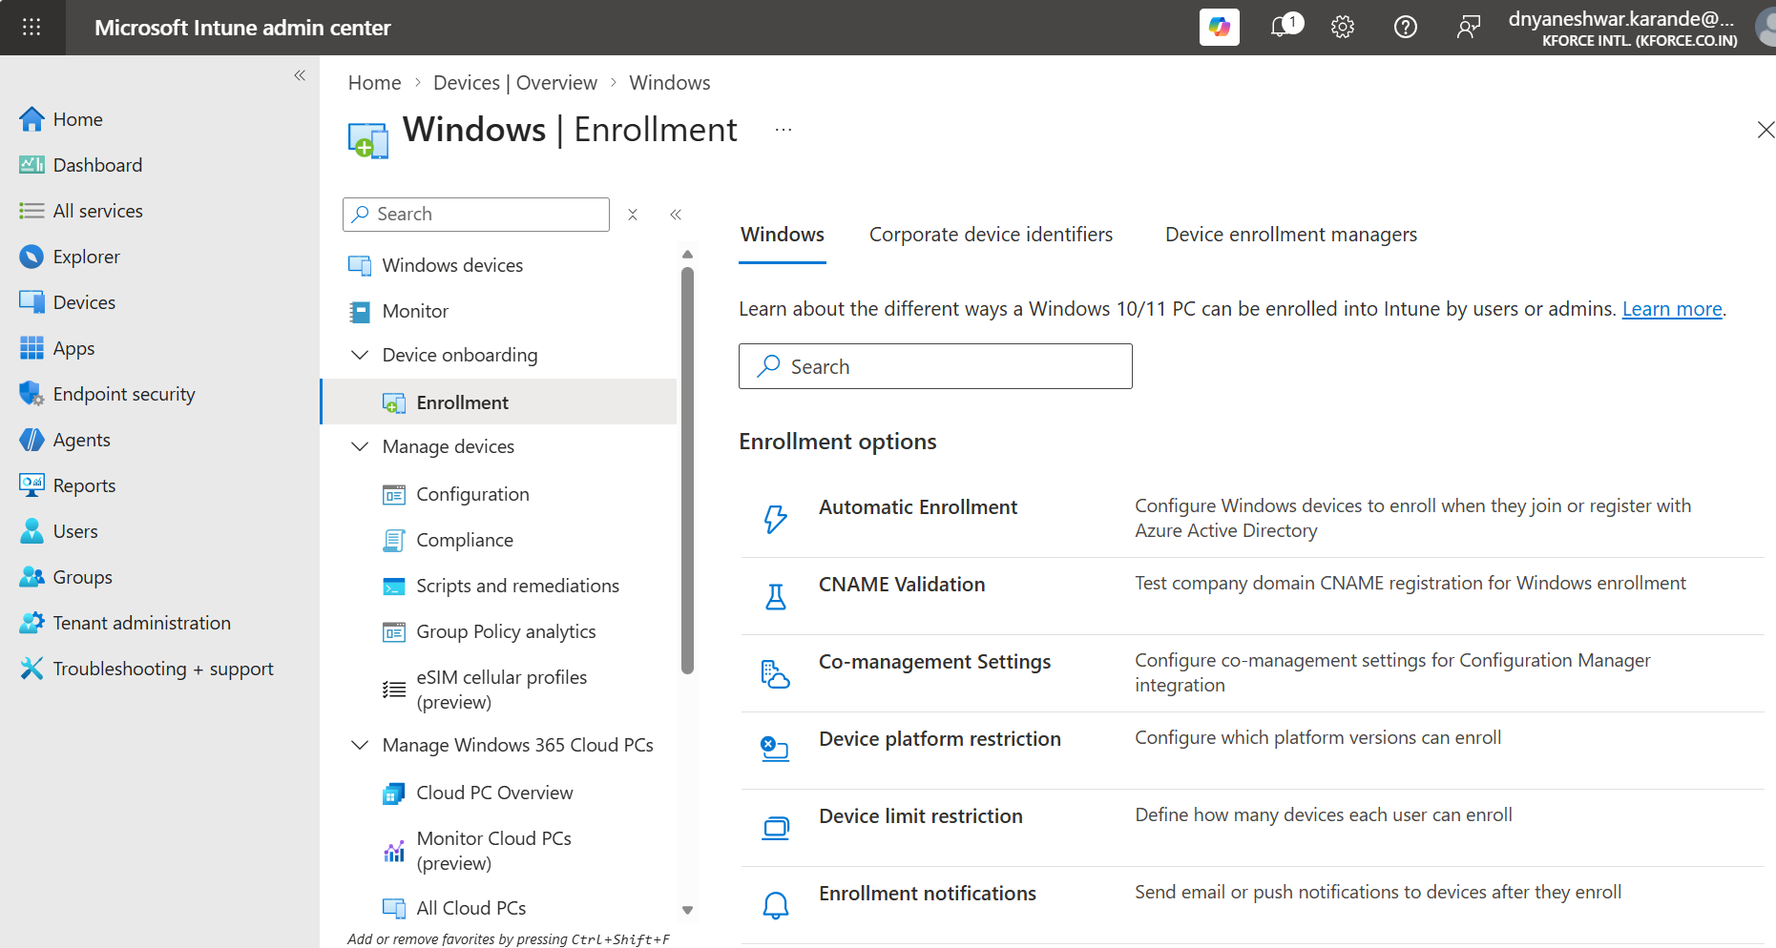
Figure 2. Windows Enrollment page and enrollment options.

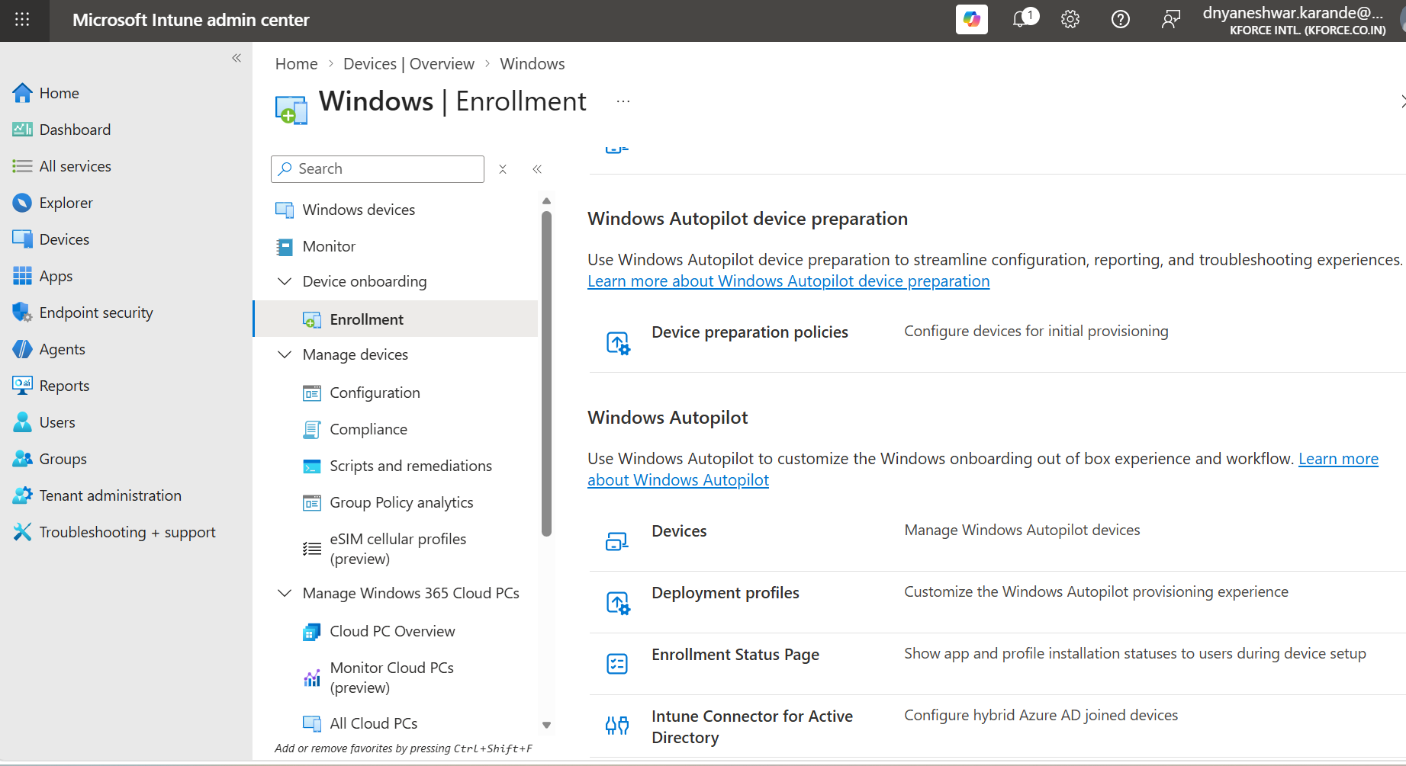
Figure 3. Windows Autopilot section includes Devices, Deployment profiles, and Enrollment Status Page.
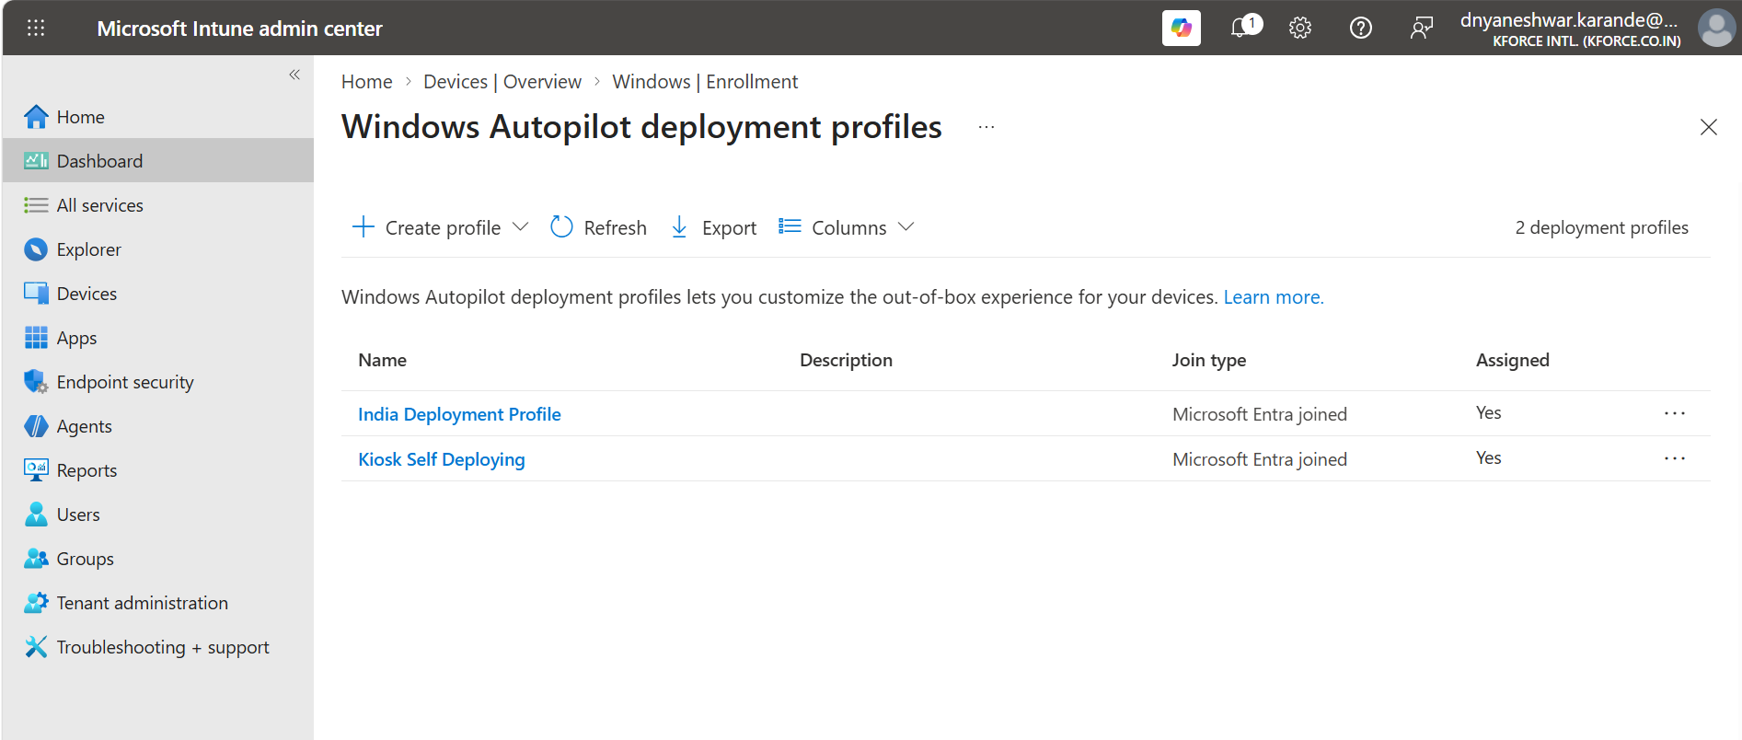
Figure 4. Windows Autopilot deployment profiles list.
Portal navigation
Current navigation generally follows Devices > Windows > Enrollment > Windows Autopilot. Portal labels can evolve, so follow the functional area rather than relying only on an old screenshot.

4. Device Registration Methods
Method | Best use | Operational note
OEM / reseller registration | New corporate purchases at scale | Provide tenant details/Group Tag through approved partner process
Manual CSV hardware hash | Pilot, test, special procurement, limited scenarios | Boot device and securely collect 4K hash
Direct online script upload | Authorized technician during OOBE or existing Windows | Requires approved administrator sign-in and permissions
Configuration Manager export | Existing managed estate | Useful for migration scenarios
Windows Settings diagnostics export | Existing Windows device | Export management logs where supported

4.1 Registration is not enrollment
Registration makes the device known to Windows Autopilot. Enrollment occurs later when the device completes the Windows setup and joins/registers to Microsoft Entra ID and Intune according to the assigned scenario.

4.2 Device transfer between tenants
- Remove assignments and retire/wipe according to organizational process.
- Confirm the Autopilot identity is deleted from the source tenant before import into the destination tenant.
- Retain proof of ownership and coordinate with OEM/CSP or Microsoft support when duplicate ownership blocks registration.
- Do not attempt to bypass ownership controls.

5. Hardware Hash Method A: Windows 11 Diagnostics Export
Use when
The new Windows 11 device is at OOBE and the Autopilot Diagnostics page is available.

- Connect charger and power on the device.
- Stop at Windows OOBE. Do not create a personal account.
- Connect to a reliable network if requested and insert an approved USB drive.
- Press Ctrl + Shift + D. If required by the keyboard, include Fn.
- Select Export logs.
- Choose a dedicated USB folder for the serial number.
- Keep the USB connected during export.
- Confirm Logs successfully exported.
- Locate the CSV in the exported logs and retain the original export as evidence.
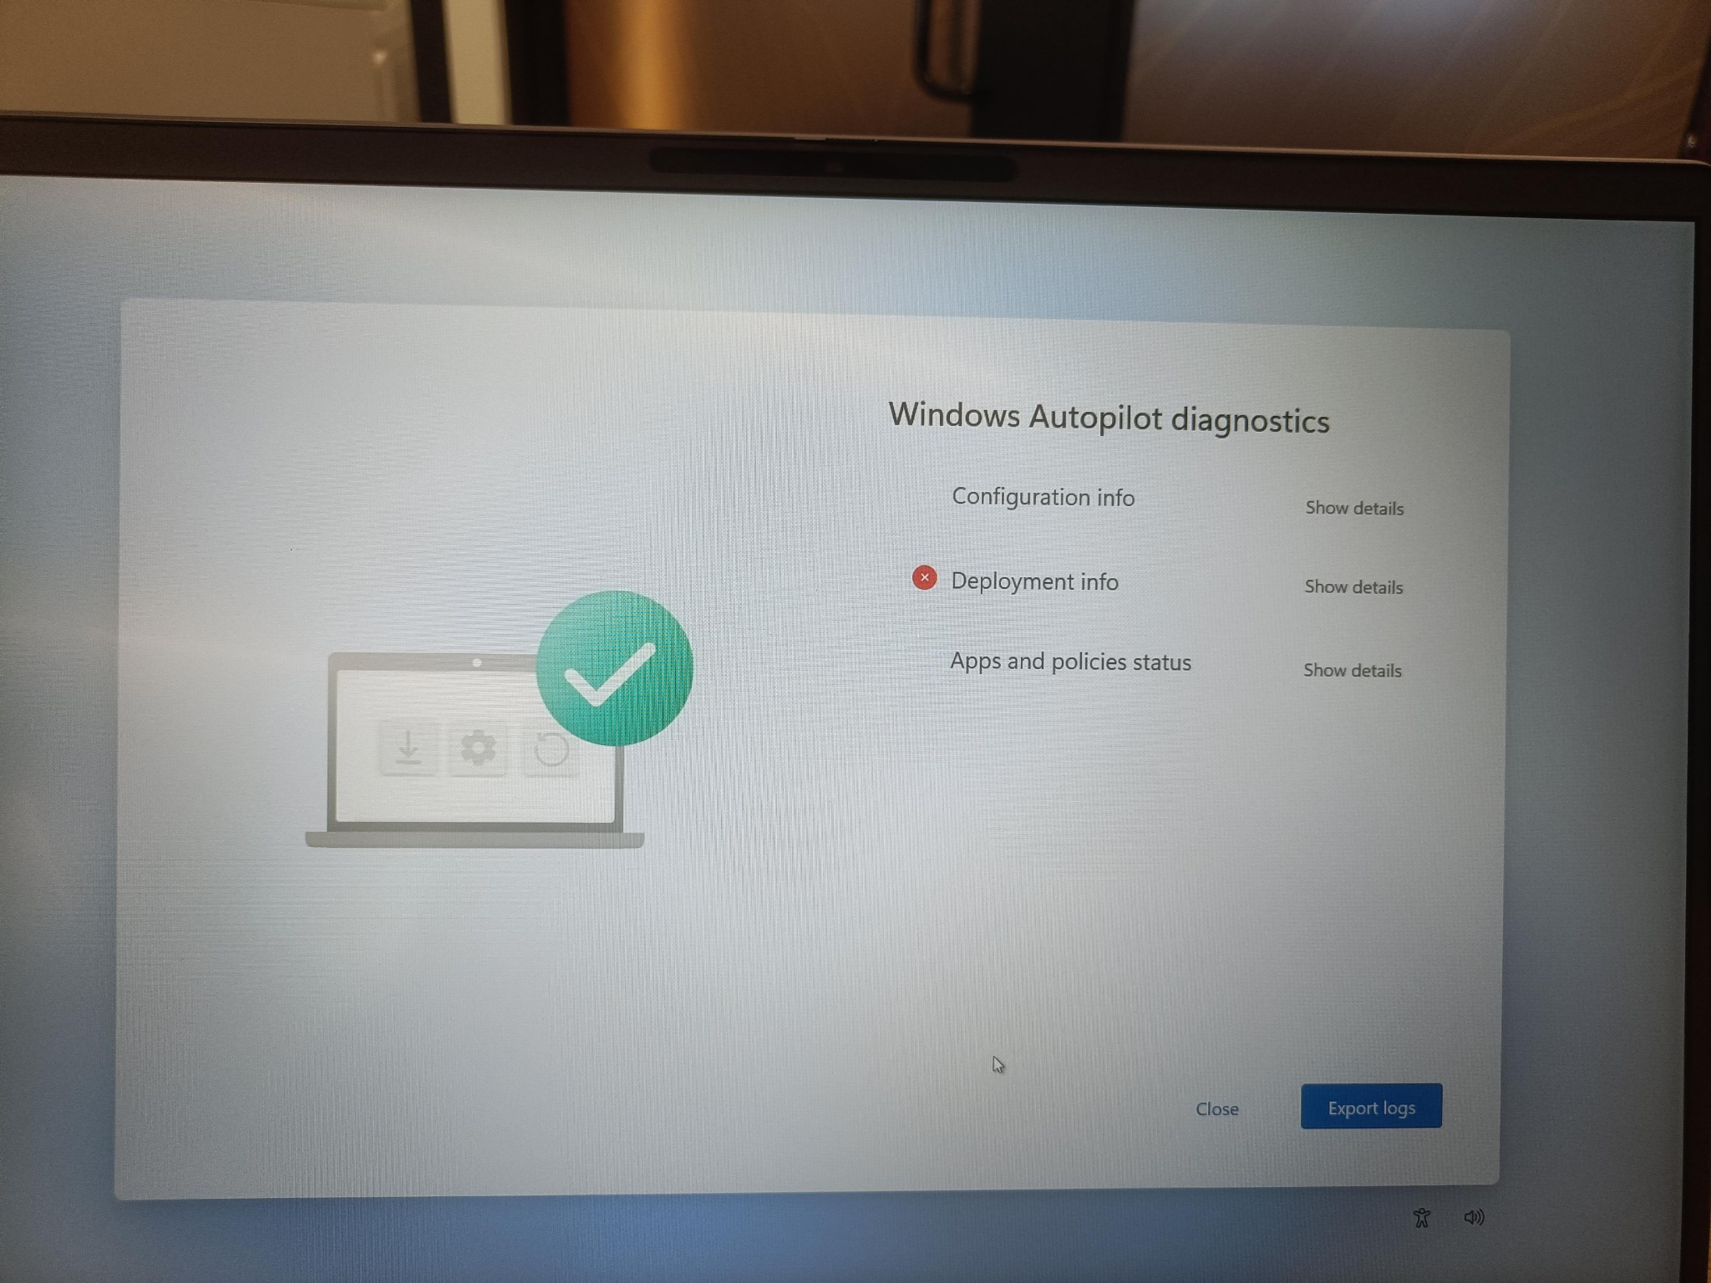
Figure 5. Autopilot Diagnostics page. Select Export logs.
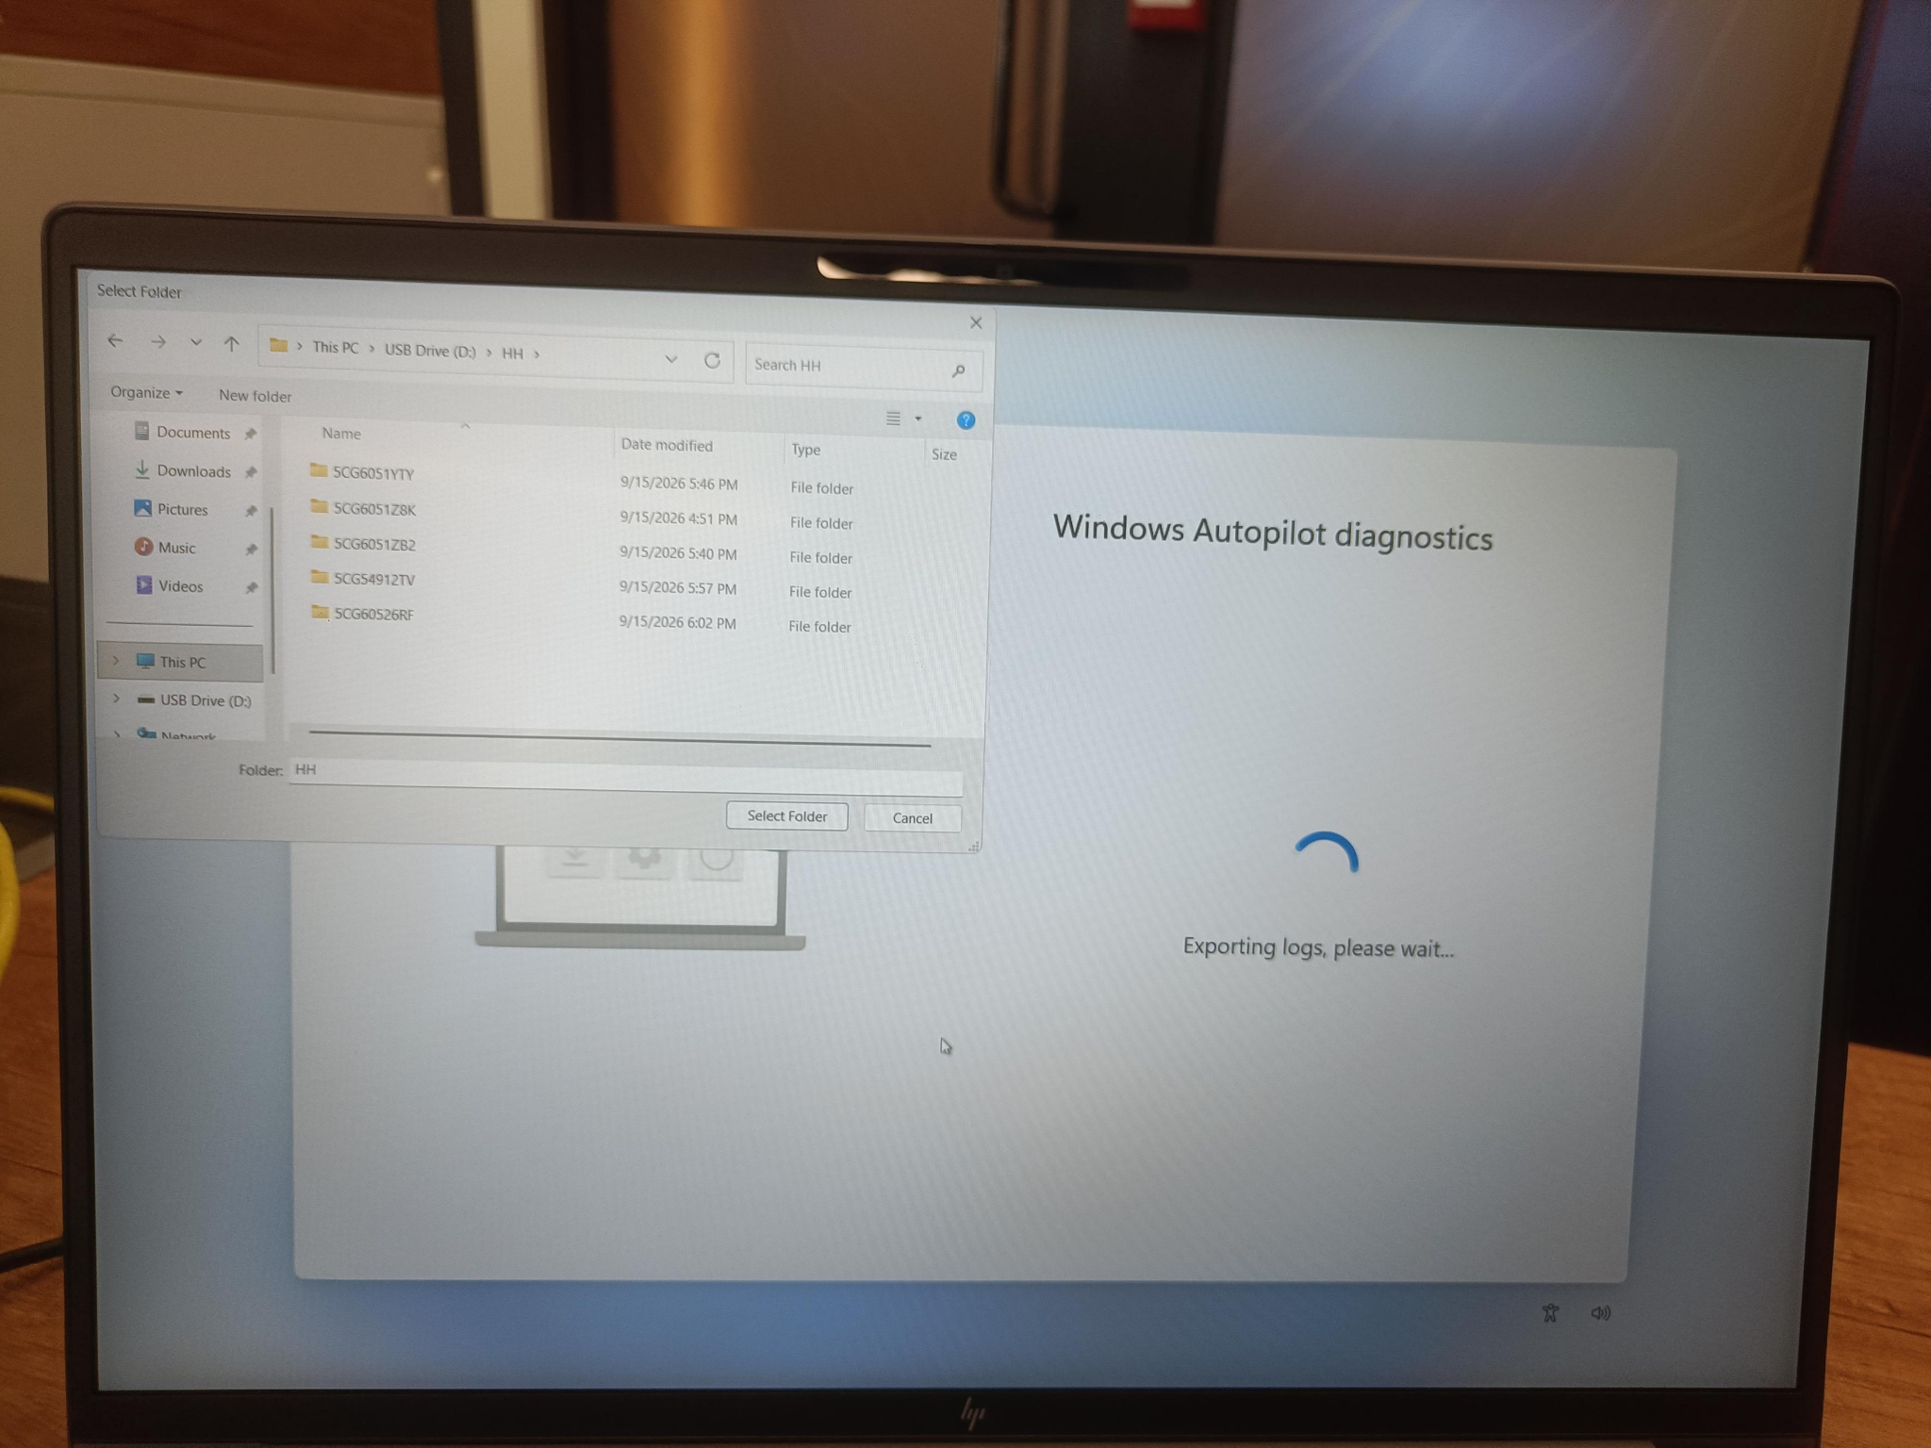
Figure 6. Select the USB destination folder.

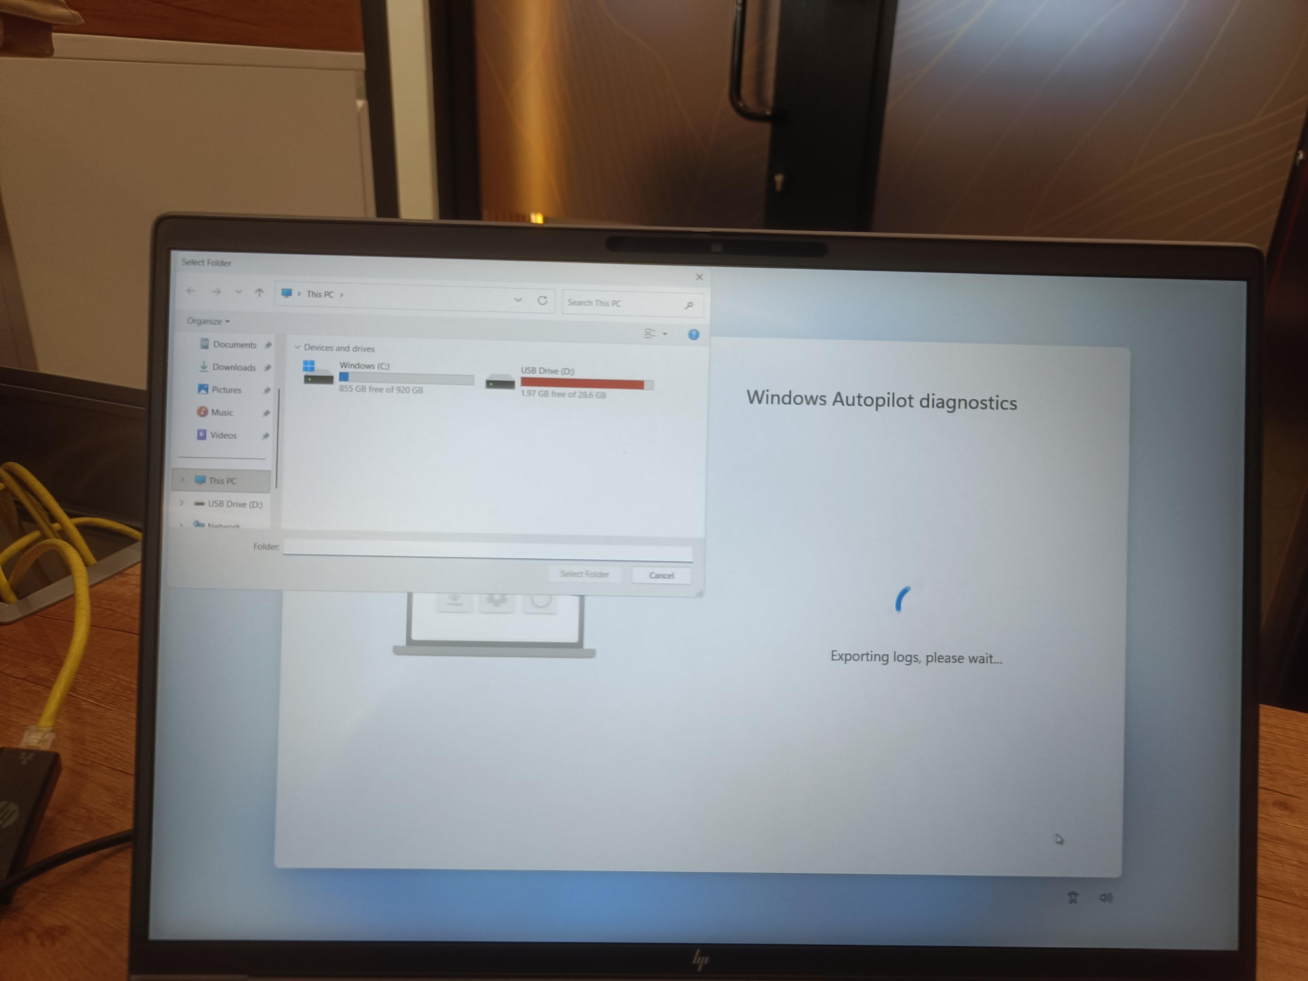
Figure 7. Exporting logs. Do not disconnect the USB drive.
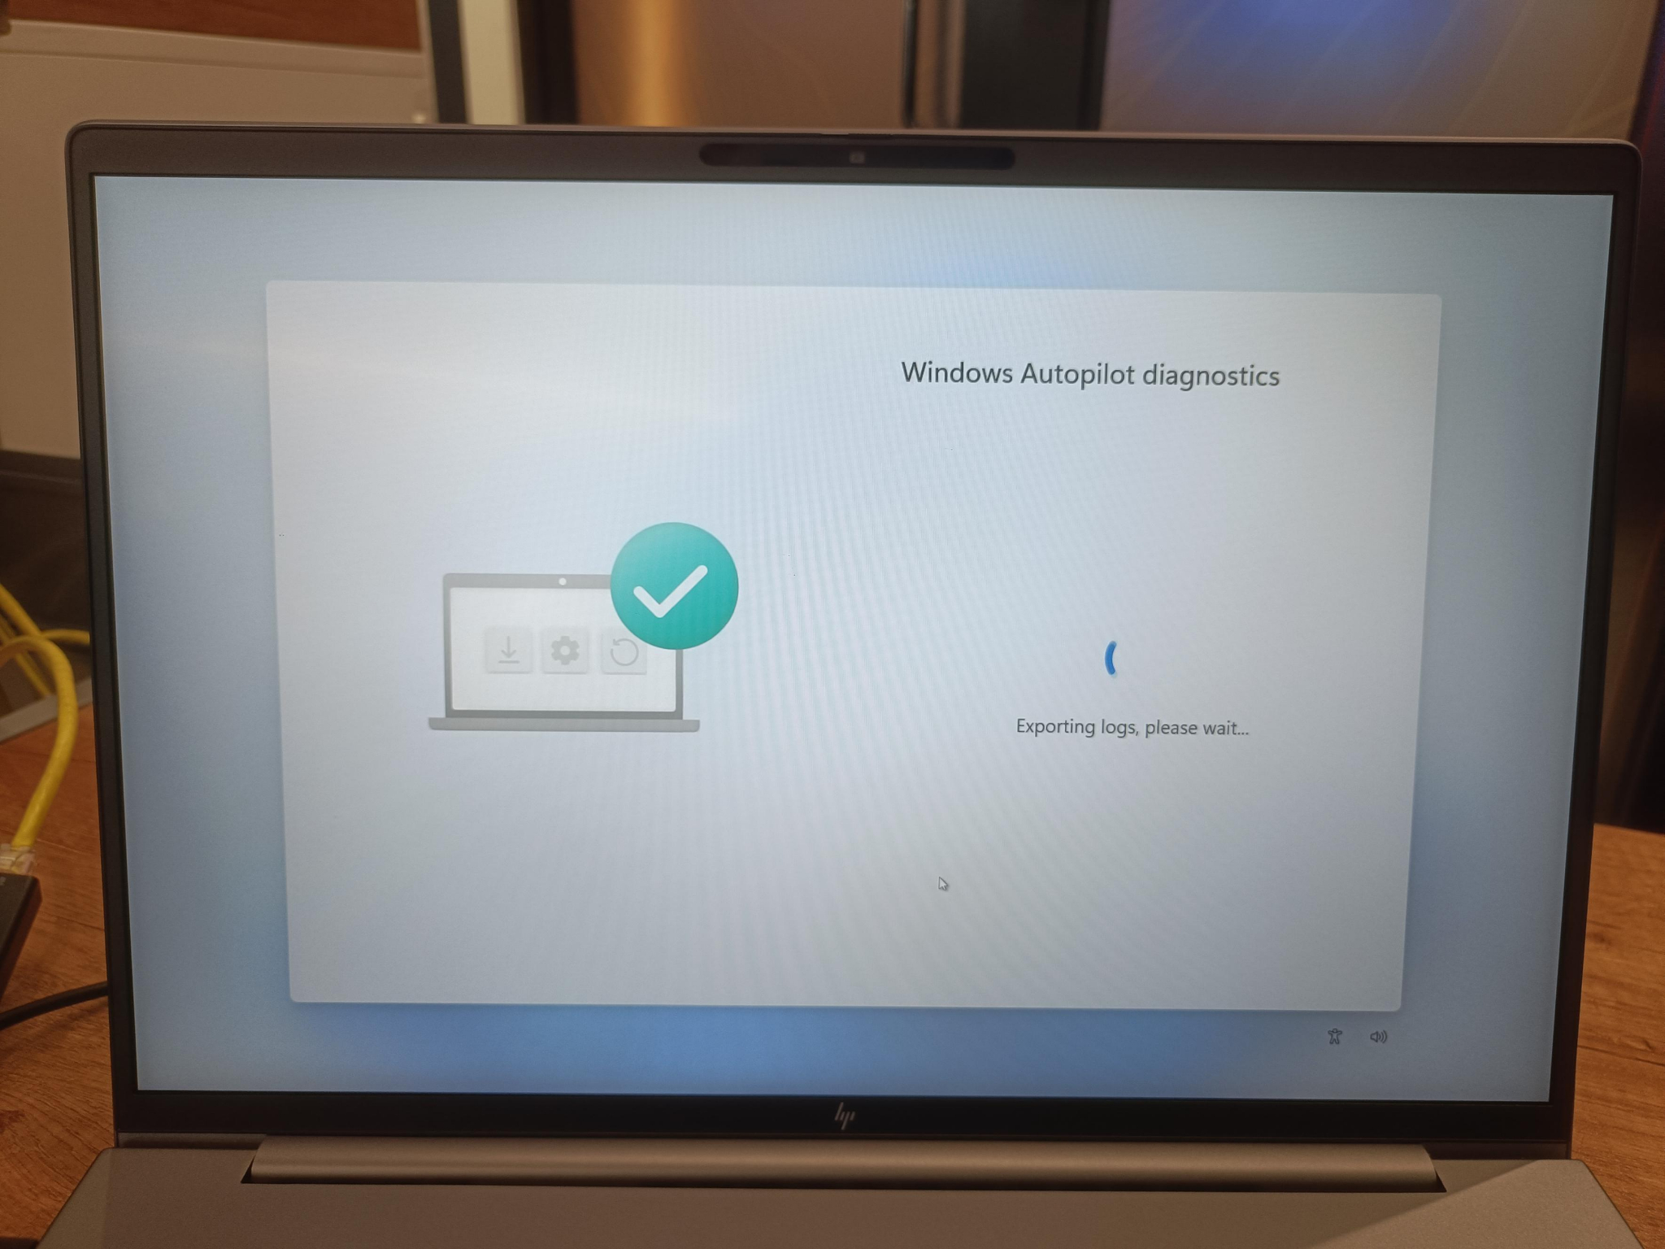
Figure 8. Export in progress.
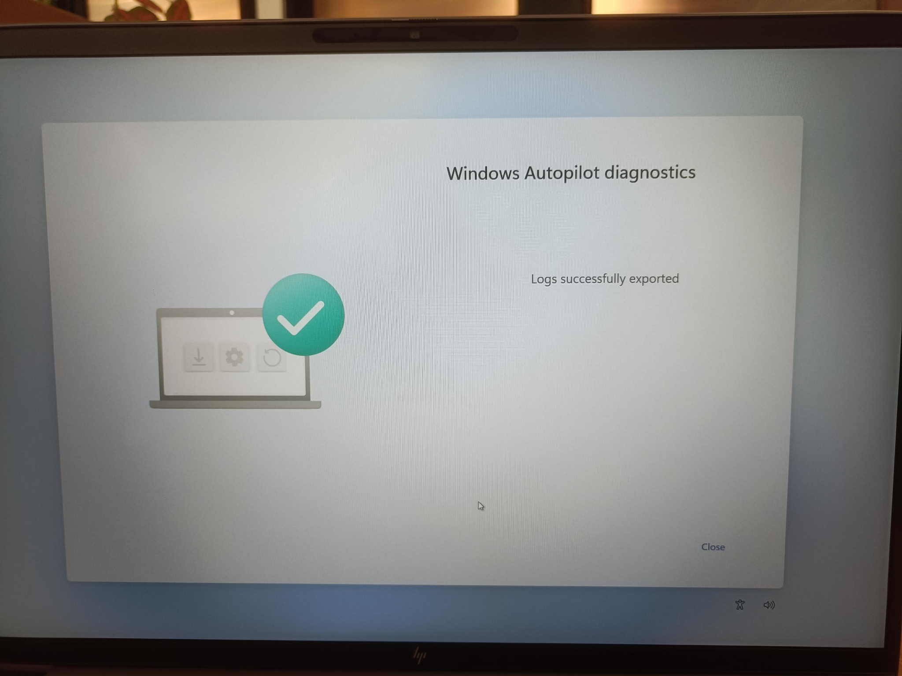
Figure 9. Logs successfully exported.

6. Hardware Hash Method B: PowerShell from OOBE

6.1 Open the tools
- At OOBE press Shift + F10. Try Fn + Shift + F10 if function keys use media mode.
- At Command Prompt, type powershell.exe and press Enter.
- Connect to internet before installing the script.
powershell.exe

6.2 Create local CSV
[Net.ServicePointManager]::SecurityProtocol = [Net.SecurityProtocolType]::Tls12
New-Item -Type Directory -Path "C:\HWID" -Force
Set-Location -Path "C:\HWID"
$env:Path += ";C:\Program Files\WindowsPowerShell\Scripts"
Set-ExecutionPolicy -Scope Process -ExecutionPolicy RemoteSigned -Force
Install-Script -Name Get-WindowsAutopilotInfo -Force
Get-WindowsAutopilotInfo -OutputFile AutopilotHWID.csv

6.3 Copy to USB
# Replace D: with the actual USB drive letter
Copy-Item "C:\HWID\AutopilotHWID.csv" "D:\AutopilotHWID_<SerialNumber>.csv"

6.4 Optional direct upload
Set-ExecutionPolicy -Scope Process -ExecutionPolicy RemoteSigned -Force
Install-Script -Name Get-WindowsAutopilotInfo -Force
Get-WindowsAutopilotInfo -Online

Control point
Direct upload requires an authorized sign-in and permissions. Use only if approved by organizational policy.

7. CSV Format, Validation, and Import

7.1 CSV columns
Device Serial Number | Windows Product ID | Hardware Hash | Group Tag
5CxxxxxxxC6 | May be blank | Complete exported value | IDC
Device Serial Number,Windows Product ID,Hardware Hash,Group Tag
5CxxxxxxxC6,,<COMPLETE_HARDWARE_HASH>,IDC

7.2 Validation checklist
- File is CSV, not XLSX or TXT.
- Header spelling/order matches supported format.
- Each device occupies one row.
- Serial number matches chassis and export.
- Hardware hash is complete and remains in one cell.
- Group Tag is approved and correctly spelled.
- No blank row above header and no extra commas.
- Keep each manual import batch within the current portal-supported limit.
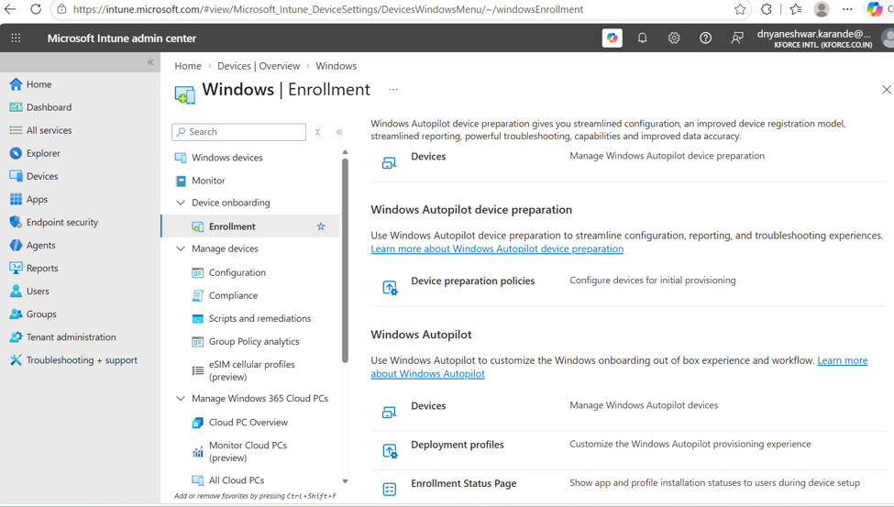
Figure 10. Windows Enrollment page. Open Windows Autopilot Devices for import.

7.3 Import
- Open Devices > Windows > Enrollment > Windows Autopilot > Devices.
- Select Import and choose the validated CSV.
- Start import and monitor notifications.
- After completion, select Sync.
- Search by serial number and confirm manufacturer, model, Group Tag, and profile status.

8. Create a Windows Autopilot Deployment Profile
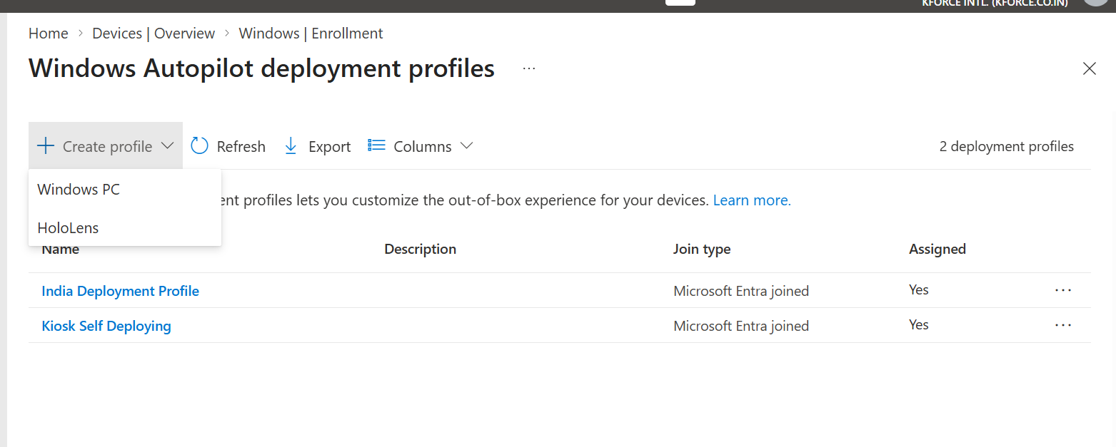
Figure 11. Select Create profile > Windows PC.
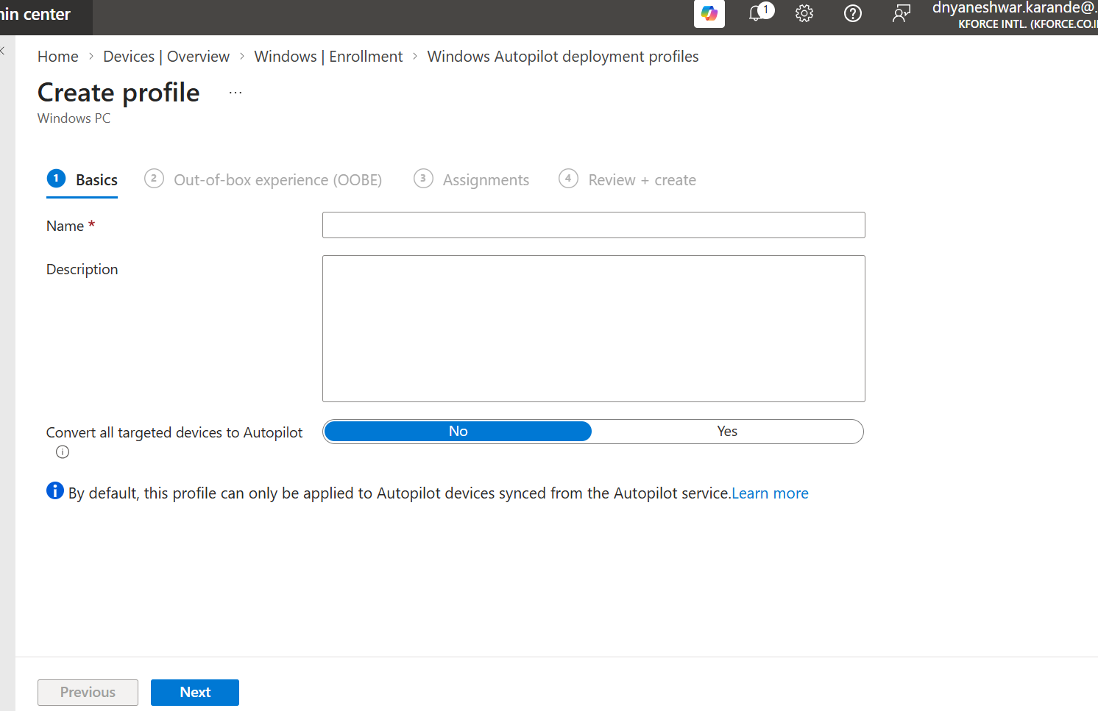
Figure 12. Basics: name, description, and Convert all targeted devices to Autopilot.

8.1 Basics decisions
Setting | Recommended design question
Name | Use location/scenario/version naming standard
Description | Owner, intended group, join type, change ticket
Convert all targeted devices to Autopilot | Enable only after impact analysis; do not use casually

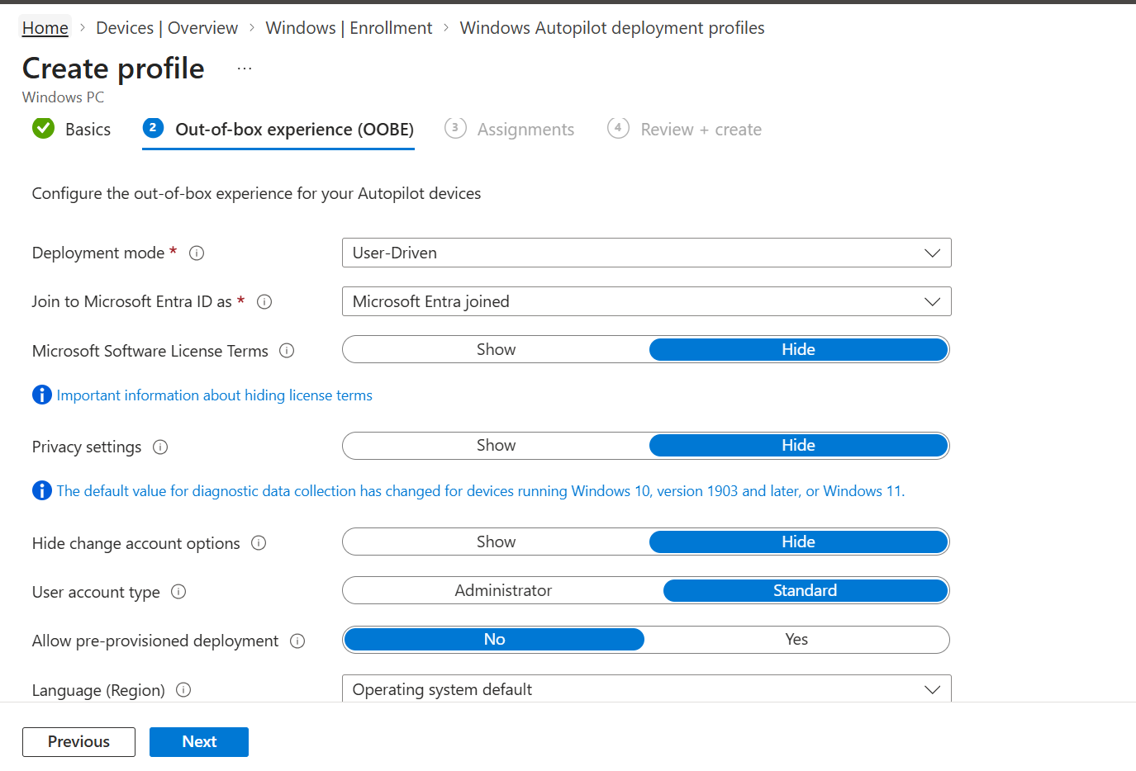
Figure 13. User-driven profile OOBE settings.

8.2 OOBE settings explained
Setting | Purpose | Typical corporate choice
Deployment mode | User-driven or Self-deploying | User-driven for assigned employee laptops
Join to Microsoft Entra ID as | Entra joined or hybrid where supported/design requires | Entra joined for cloud-native
License terms | Show or hide Microsoft license page | Hide when approved
Privacy settings | Show or hide privacy page | Hide when approved
Hide change account options | Restricts alternate account options | Hide
User account type | Standard or Administrator | Standard
Allow pre-provisioned deployment | Enables technician phase | Yes when staging is used
Language/region | OOBE language handling | OS default or required locale
Automatically configure keyboard | Keyboard setup behavior | Choose based on region design
Apply device name template | Names device during deployment | Use tested template and length rules
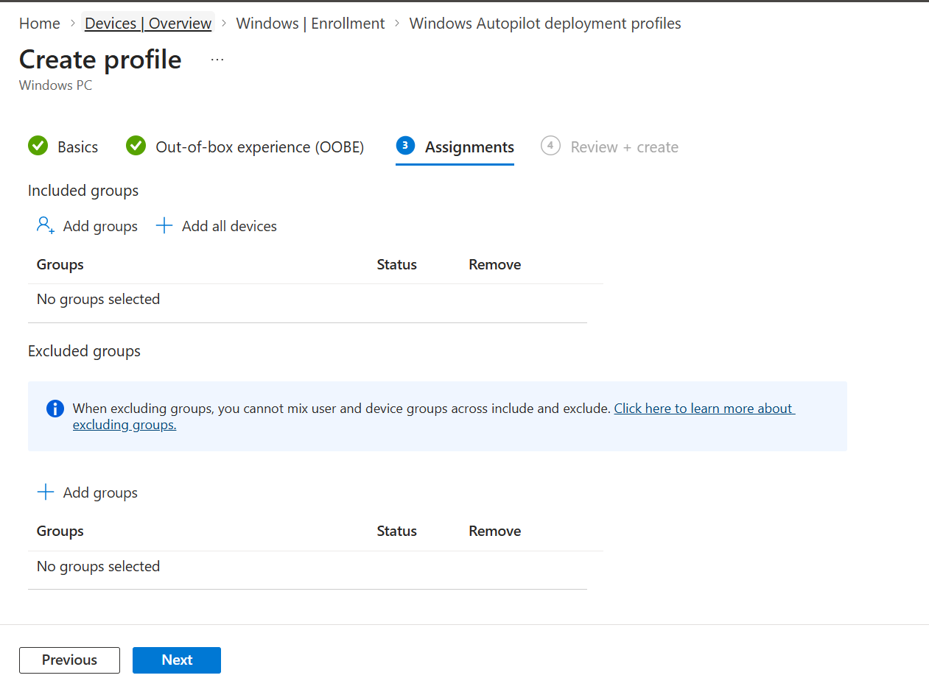
Figure 14. Assign the profile to approved device groups.
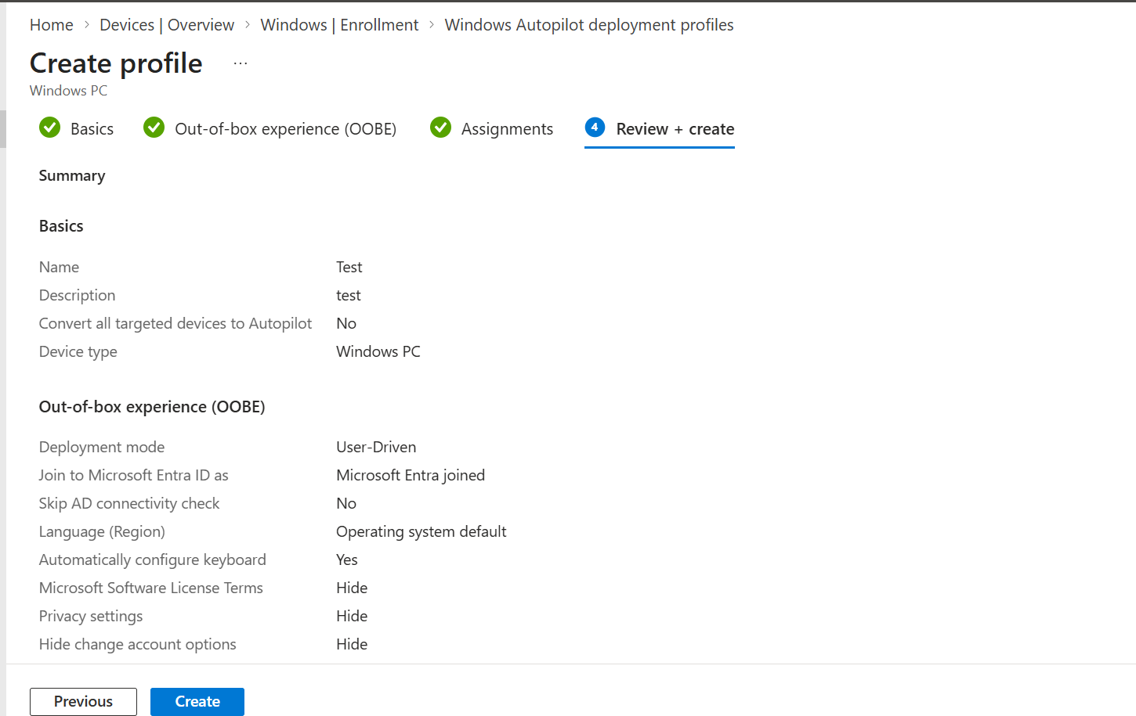
Figure 15. Review profile settings before Create.

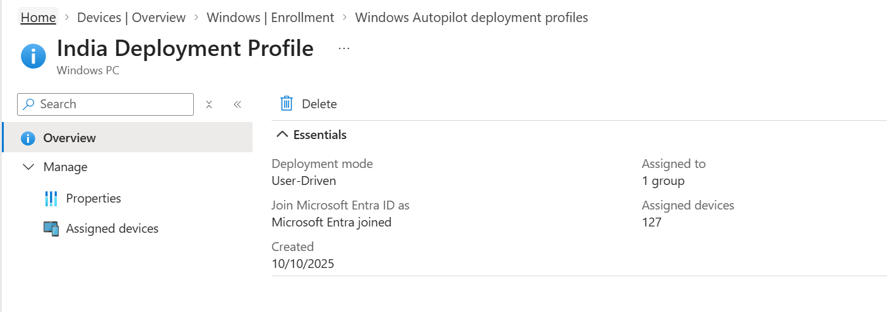
Figure 16. Deployment profile overview after creation.
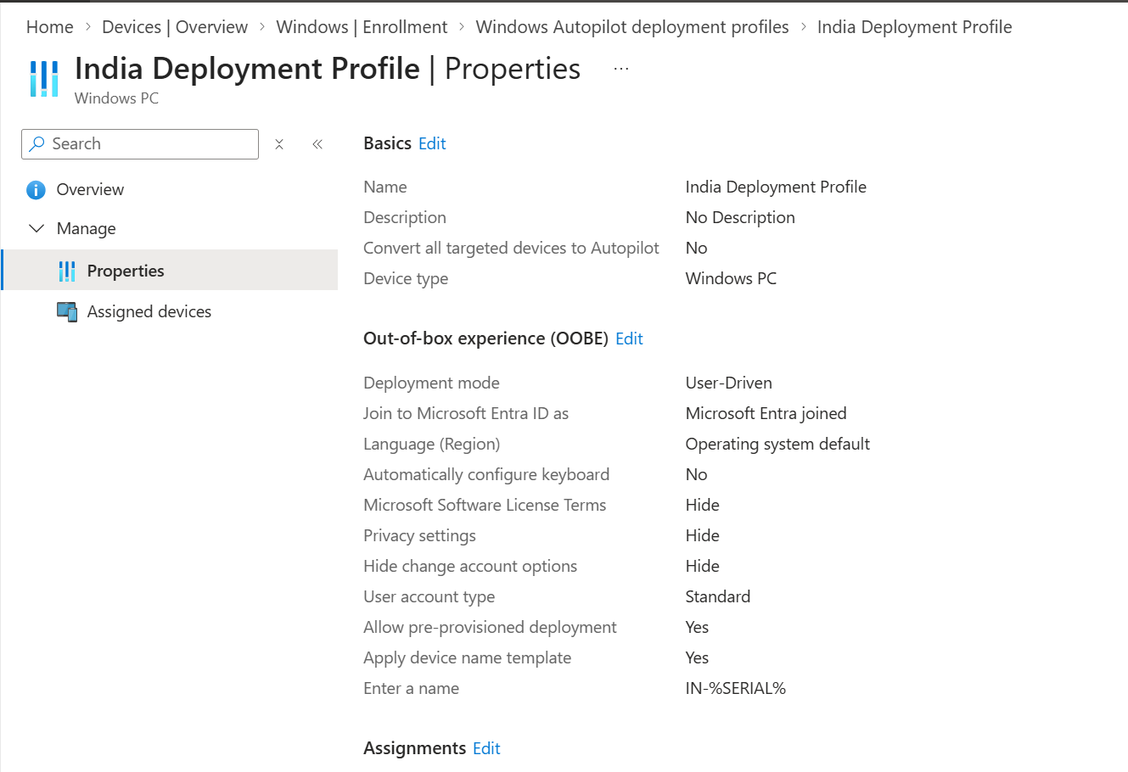
Figure 17. India Deployment Profile properties.
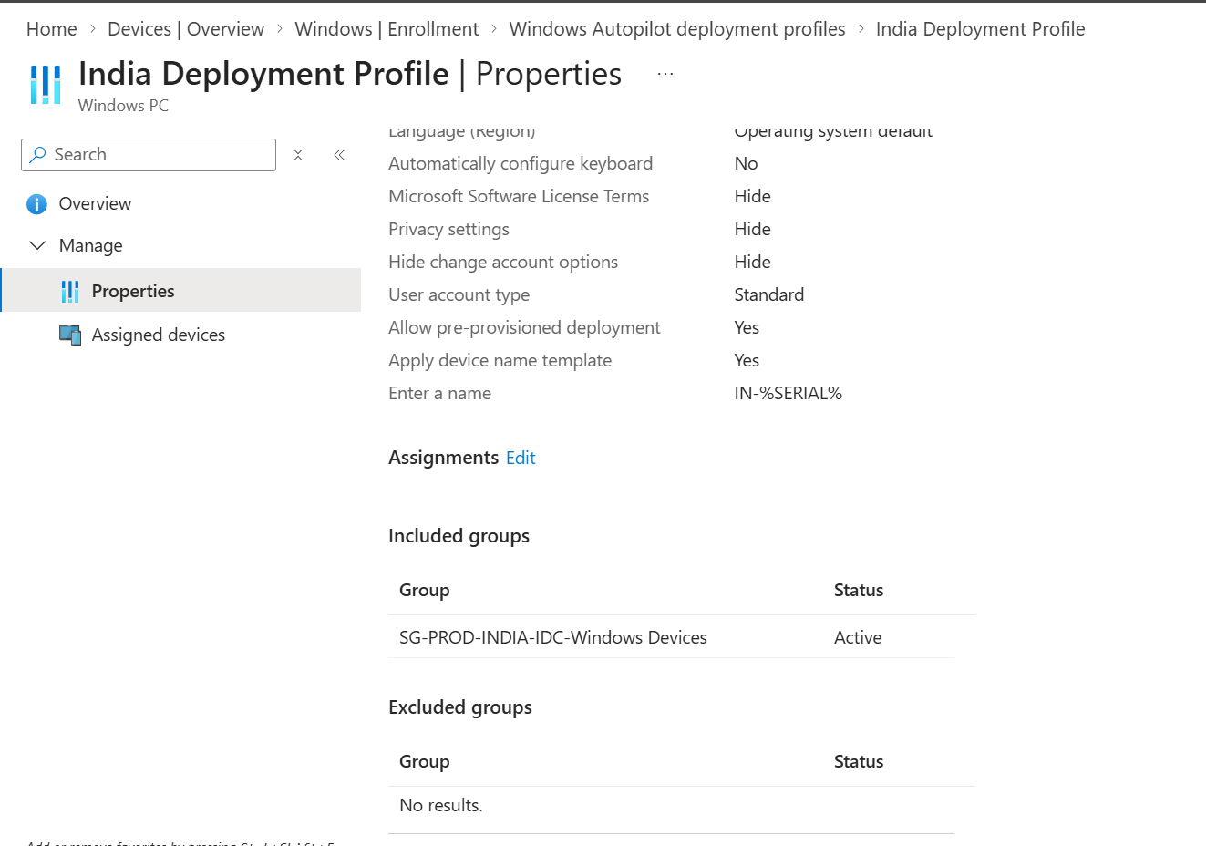
Figure 18. Profile assignment and device naming template.
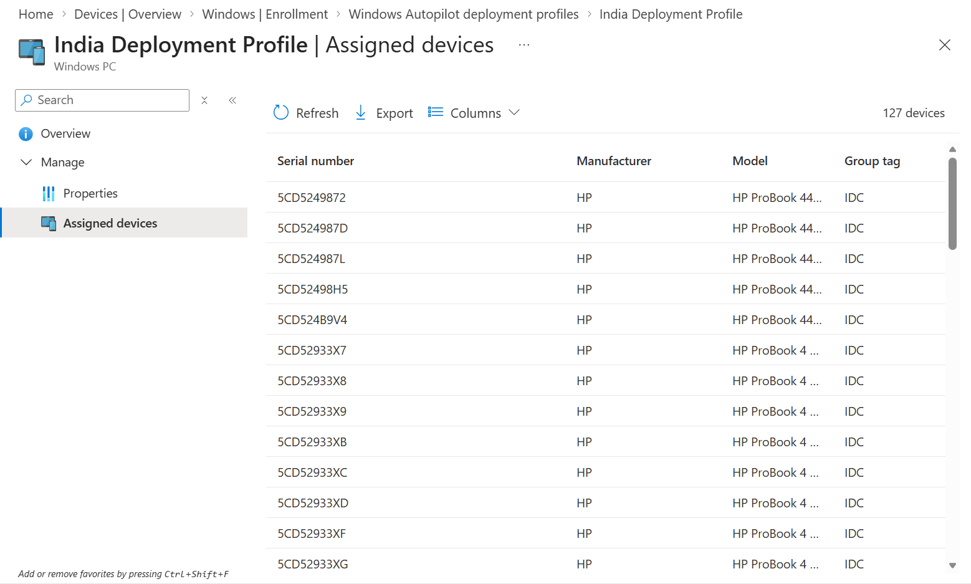
Figure 19. Assigned devices and Group Tag validation.

9. Deployment Scenarios and When to Use Them
Scenario | Use case | Identity / interaction
User-driven Microsoft Entra join | Standard assigned employee laptop | User signs in during OOBE
Self-deploying mode | Kiosk/shared device with no primary user sign-in during setup | Device-driven; TPM attestation and supported hardware/network required
Pre-provisioning | IT/OEM stages device before user handover | Technician flow then user flow
Existing devices | Reimage/migrate supported existing Windows estate | Task sequence or supported conversion workflow
Windows Autopilot device preparation | Newer policy-based deployment model for supported Windows 11 scenarios | Separate model from classic registered-device Autopilot

9.1 User-driven
- Register device and assign profile.
- Ensure profile status is Assigned.
- User connects to network and signs in with work credentials.
- Device joins Microsoft Entra ID and enrolls in Intune.
- ESP processes required device and user setup.

9.2 Self-deploying
- Use for kiosk or shared devices where scenario is supported.
- Validate TPM 2.0 attestation, network, and hardware support.
- Do not assume user-targeted apps/policies will apply without a user context.
- Use device-targeted policies and applications.
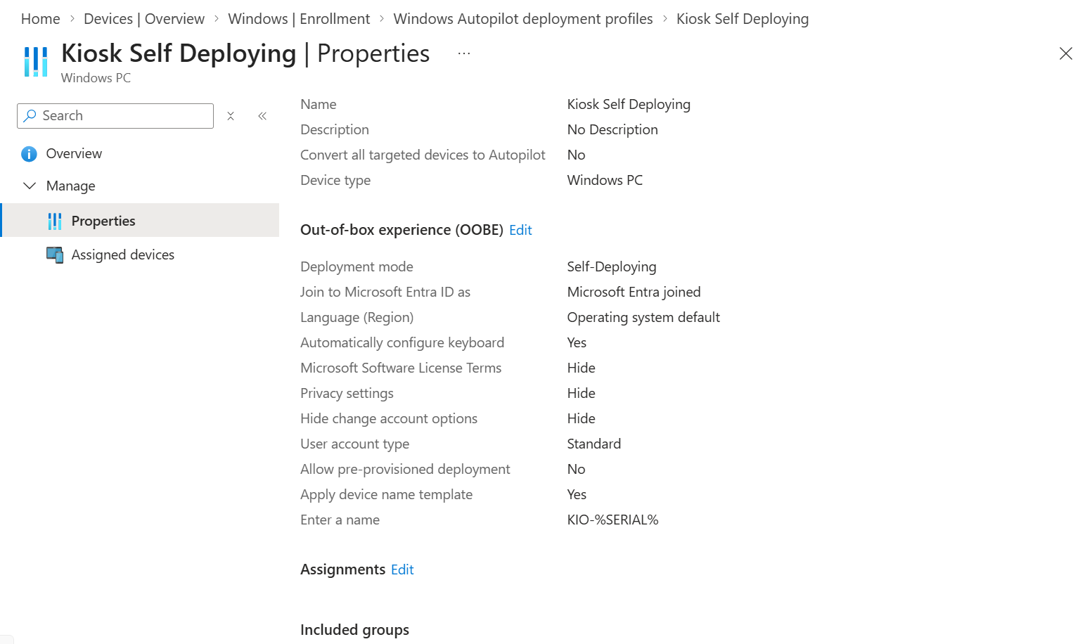
Figure 20. Example self-deploying profile properties and device name template.

10. Windows Autopilot Device Records and Status
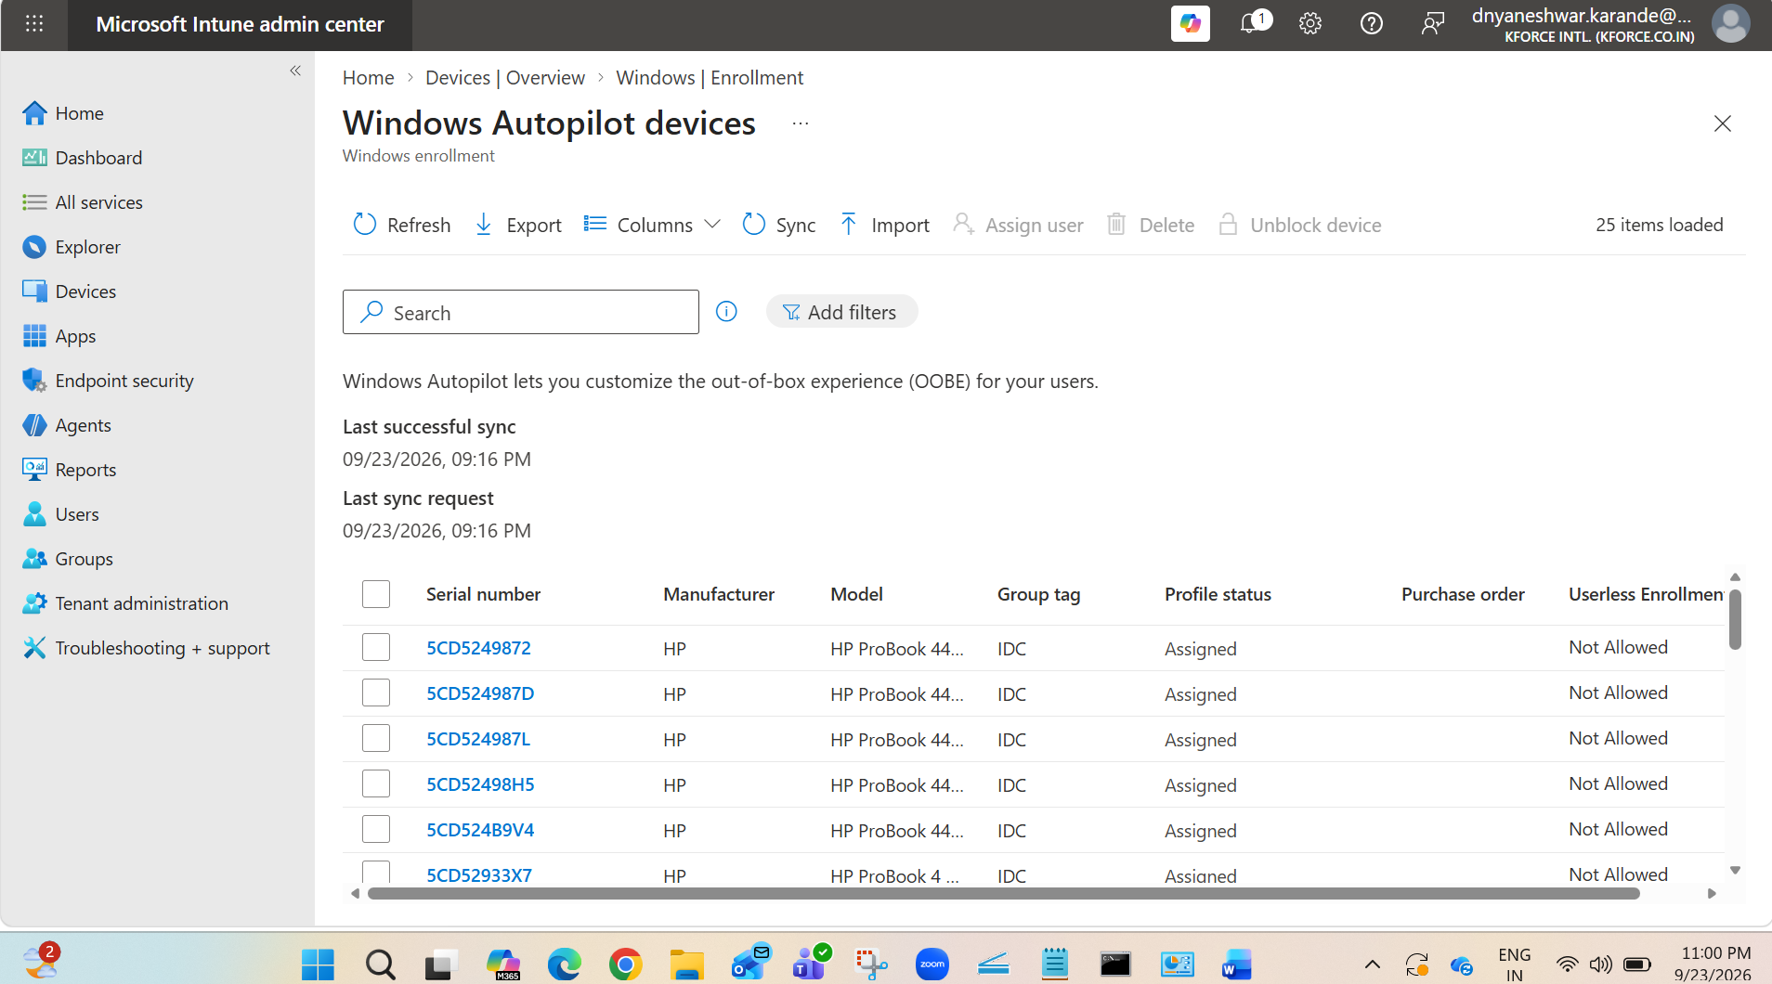
Figure 21. Windows Autopilot devices list with Group Tag and Profile status.
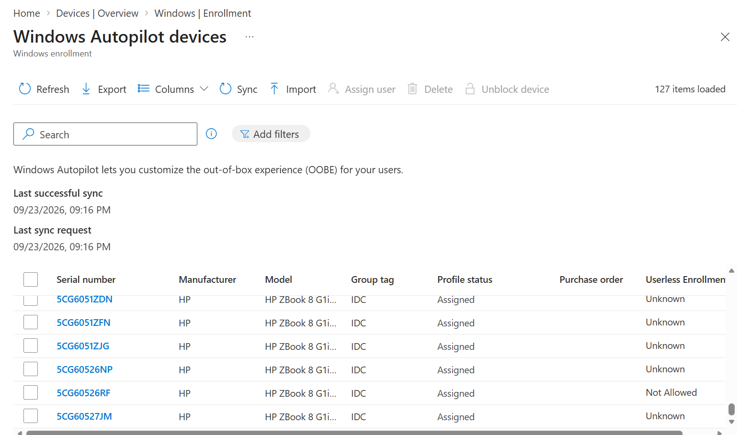
Figure 22. Device list after Sync. Search by serial number.
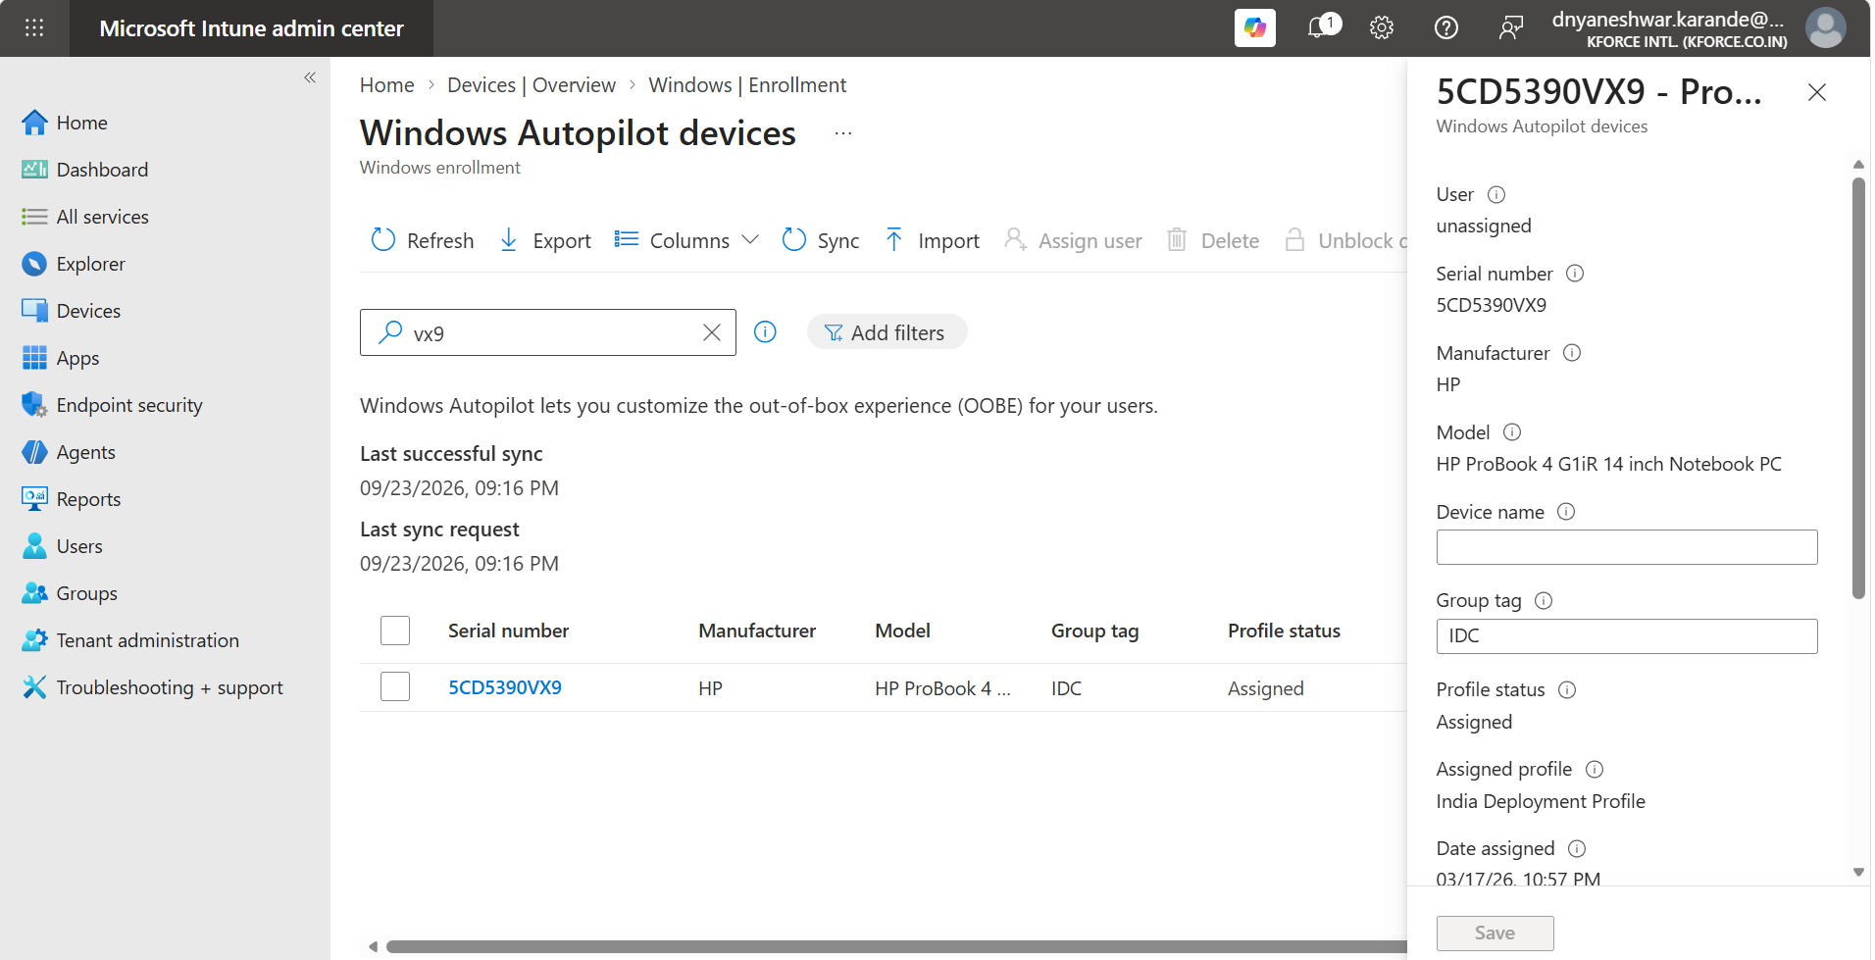
Figure 23. Autopilot device details include serial, manufacturer, model, Group Tag, and assigned profile.
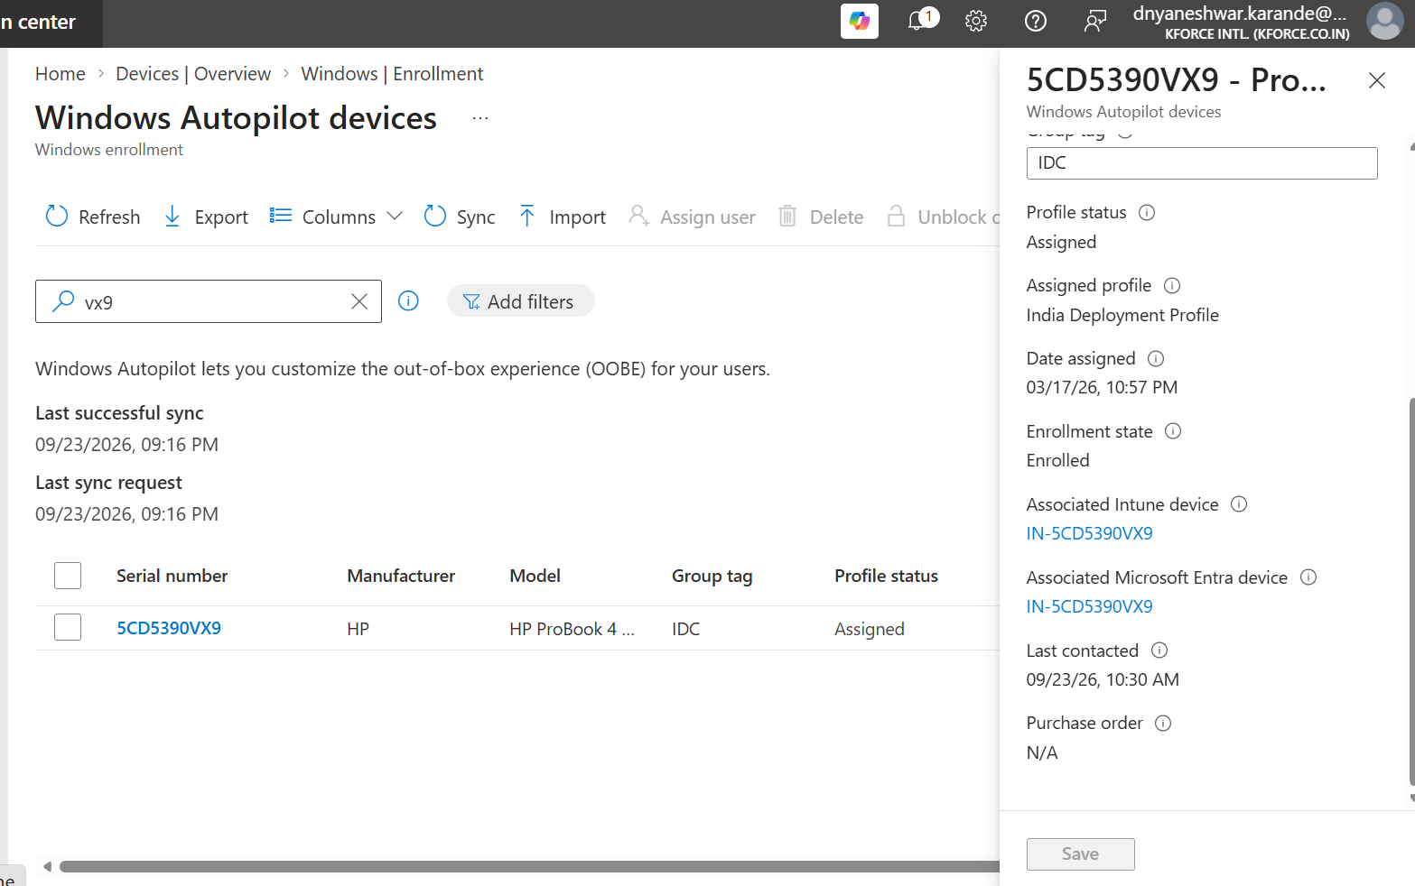
Figure 24. Enrolled device association and assigned profile status.

10.1 Status interpretation
Field | Meaning | Action
Profile status Assigned | Deployment profile delivered to Autopilot service | Ready for clean OOBE validation
Profile status Not assigned | No effective deployment profile yet | Check group membership and assignment
Group Tag | Targeting metadata | Confirm exact approved value
Associated Intune device | Link to managed device after enrollment | Use for device actions and compliance
Associated Entra device | Directory device relationship | Validate join and duplicate records
Last contacted / sync | Service/device activity indicator | Use with other logs; not a complete health signal

11. Group Tags, Groups, Naming, and Assignment Design

11.1 Example dynamic membership concept
(device.devicePhysicalIds -any (_ -eq "[OrderID]:IDC"))

Validate syntax
Dynamic membership rules and physical ID formats must be tested in the current Microsoft Entra portal. Use a pilot group and membership validation before assigning production profiles.

11.2 Naming template principles
- Stay within Windows computer-name limits.
- Use stable identifiers such as serial where supported.
- Avoid personally identifying information in device names.
- Document collisions, replacement, re-use, and renamed-device handling.
- Confirm the name template shown in the profile matches operational standards.

11.3 Assignment consistency
- Use one authoritative profile for a device.
- Avoid overlapping profiles and broad groups.
- Separate pilot, production, kiosk, and regional scenarios.
- Use exclusions carefully and document precedence.
- Wait for group evaluation and Autopilot sync before OOBE.

12. Enrollment Status Page (ESP)

12.1 Purpose
ESP displays and tracks device preparation, device setup, and account setup during enrollment. It can block device use until selected policies and applications complete.

12.2 Design checklist
Setting area | Guidance
Show progress | Enable for controlled corporate deployment
Block device use | Use only for essential setup
Timeout | Set based on real pilot evidence
Error handling | Define support path and reset/retry guidance
Block on selected apps | Keep the list minimal and highly reliable
User ESP | Consider sign-in time and user-targeted app reliability

12.3 Blocking app selection
- Security agent and management prerequisites.
- Applications required before productive or compliant use.
- Avoid large, user-optional, frequently changing, or unreliable applications.
- Use Win32 apps consistently during classic Autopilot where possible to reduce installer conflicts.

12.4 ESP troubleshooting stages
Stage | Typical checks
Device preparation | Network, TPM, join, enrollment, IME installation
Device setup | Device-targeted apps, policies, certificates, security baselines
Account setup | User-targeted apps, user policy, licensing, sign-in

13. Applications, Configuration, Compliance, and Security
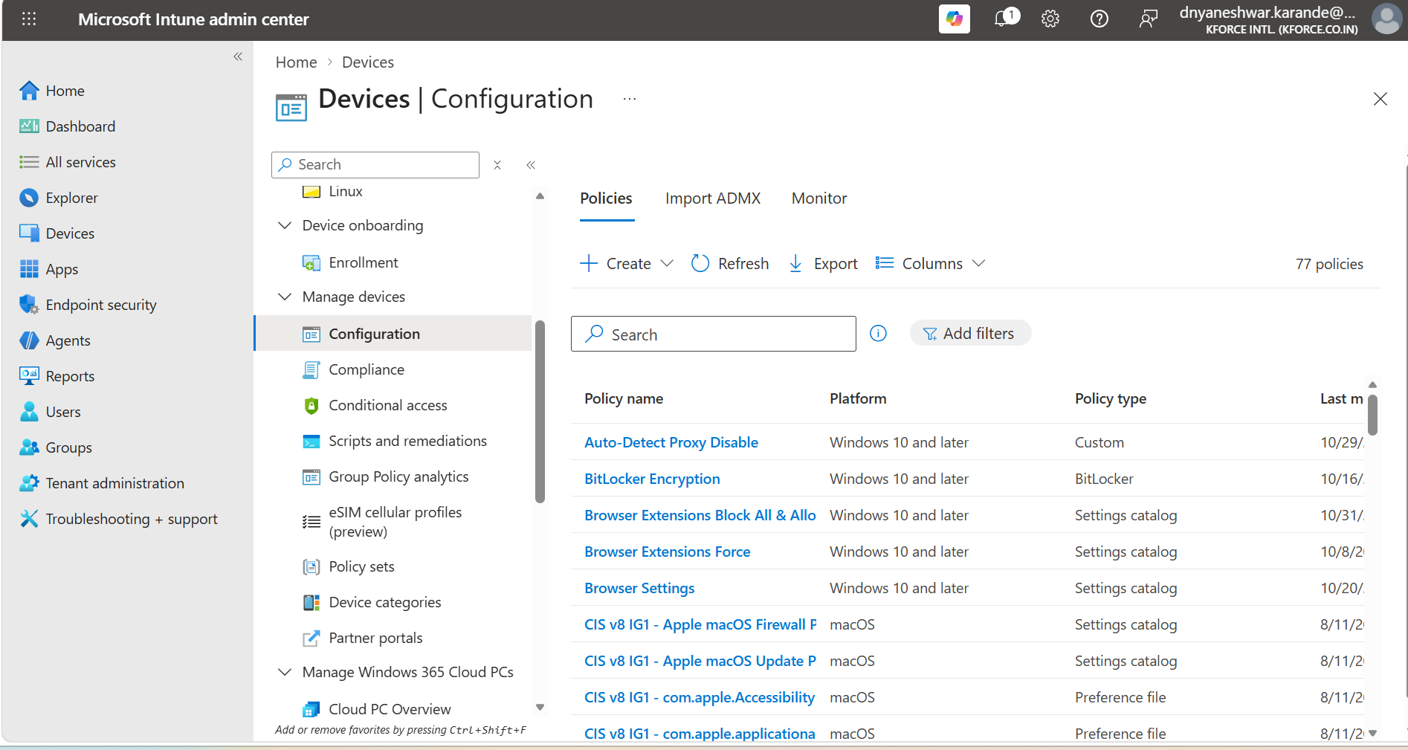
Figure 25. Devices > Configuration policy list.
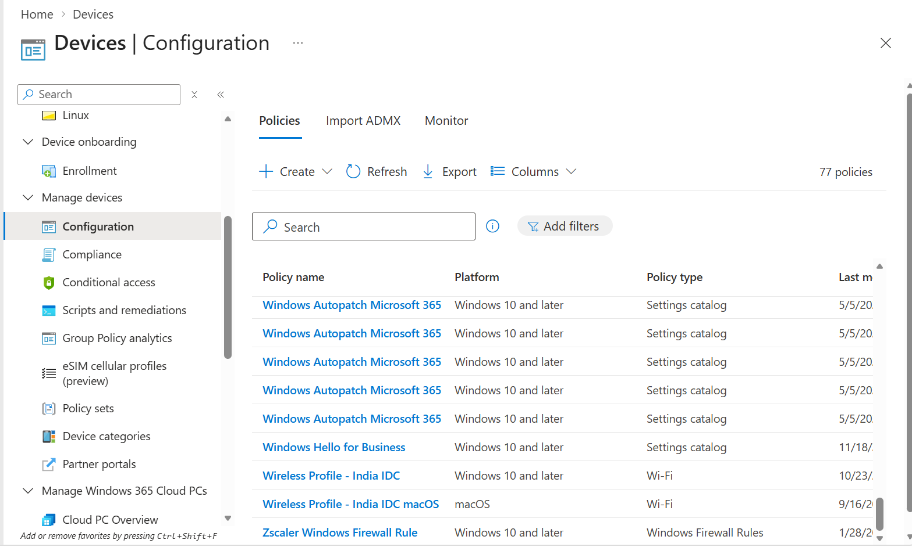
Figure 26. Windows configuration profiles used with the deployment.
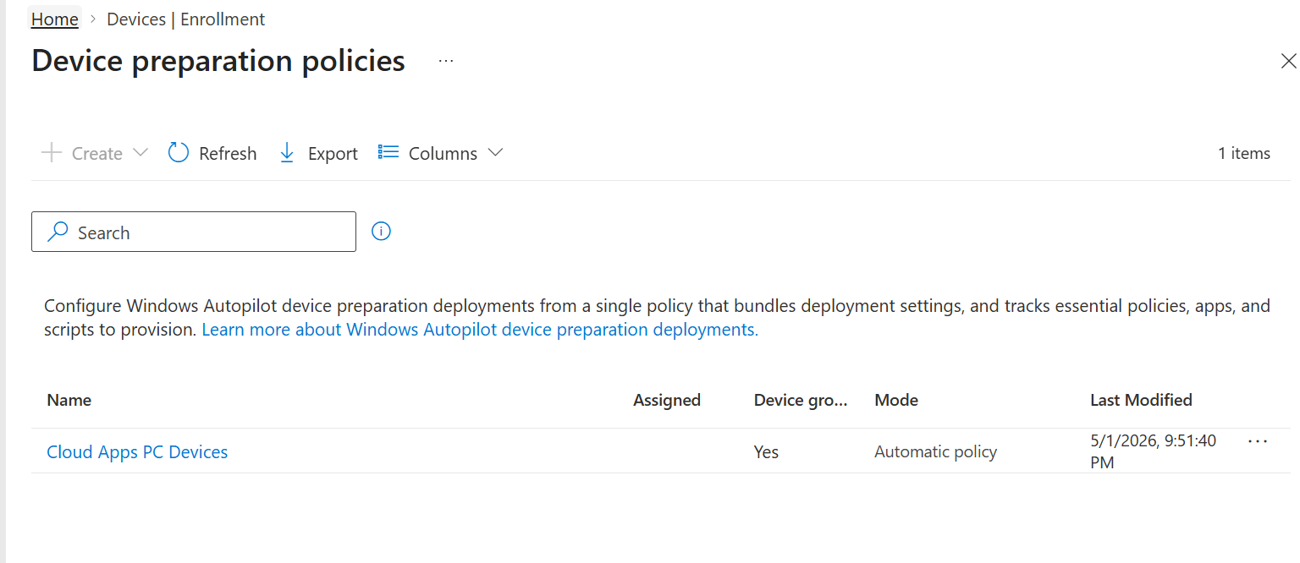
Figure 27. Device preparation policies area shown in the tenant.

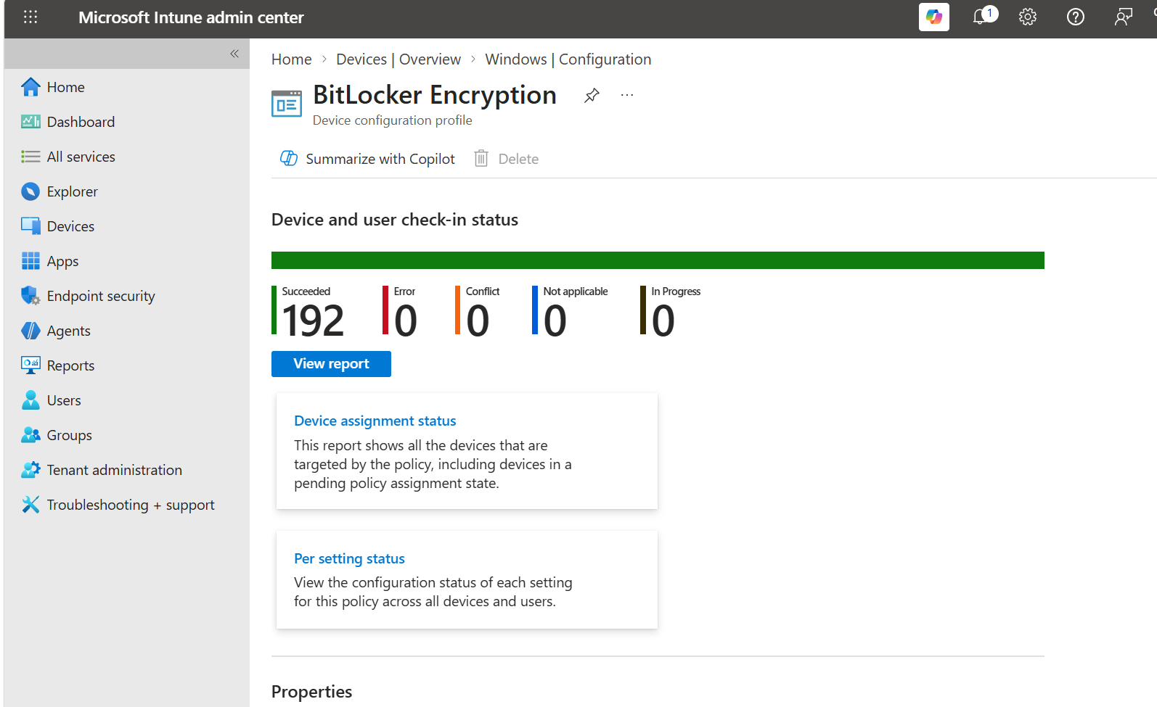
Figure 28. BitLocker Encryption profile monitoring.
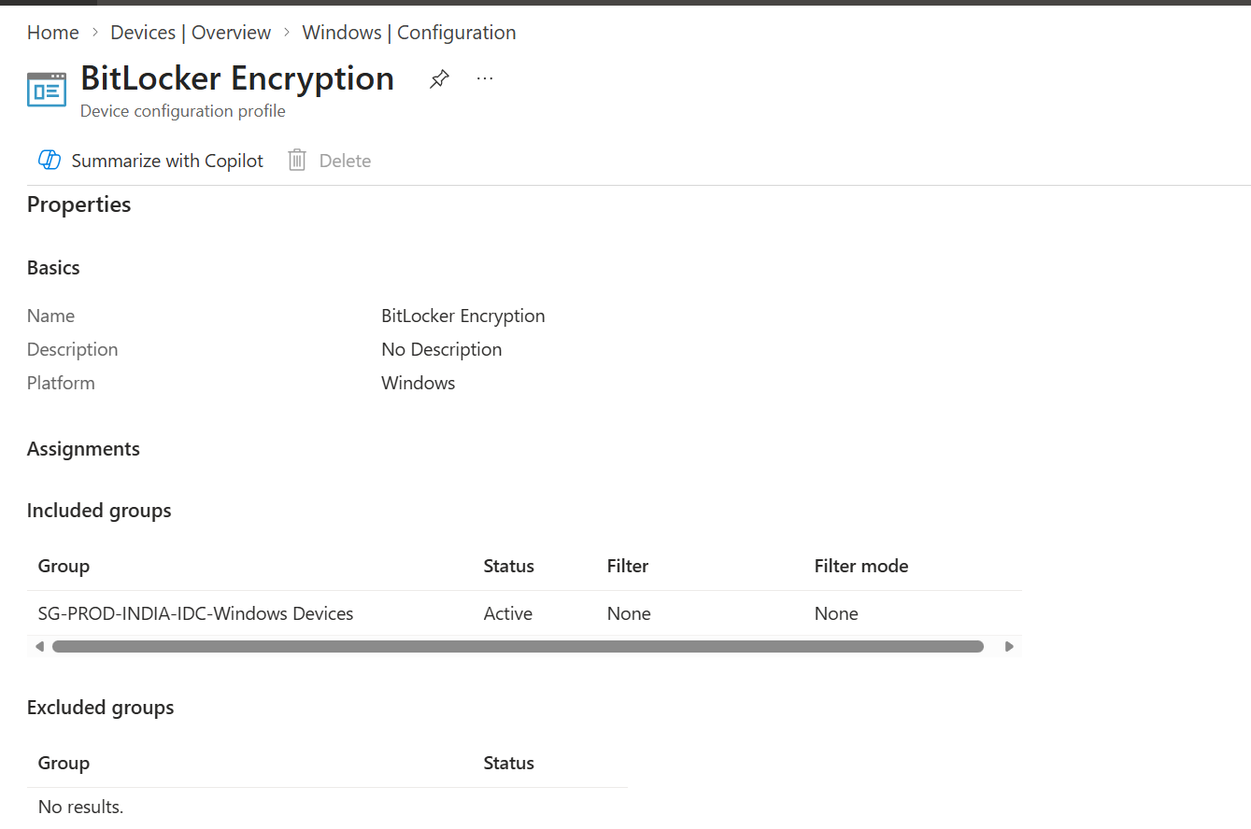
Figure 29. BitLocker profile assignments to the Windows device group.
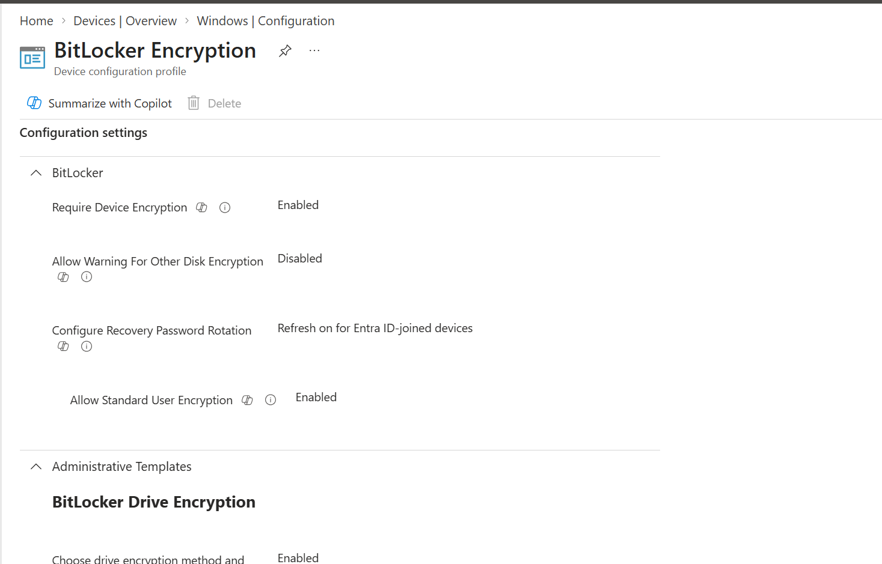
Figure 30. BitLocker configuration settings.
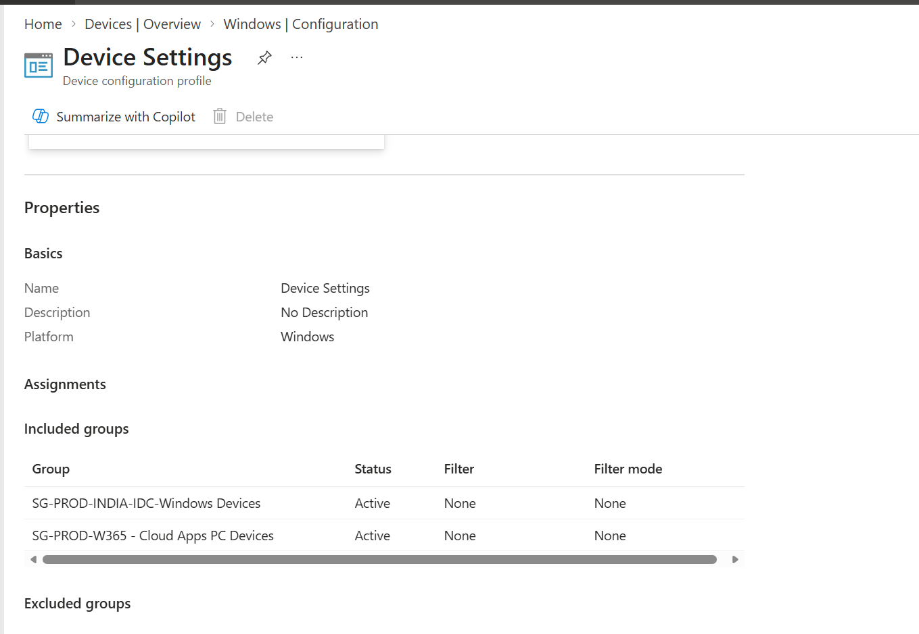
Figure 31. Device Settings profile assignments.

13.1 Baseline workload categories
Category | Examples
Security | BitLocker, Defender, firewall, security baseline, LAPS
Identity | Windows Hello for Business, authentication, SSO
Connectivity | Wi-Fi, VPN, certificates, proxy
Device configuration | Restrictions, browser, OneDrive, Edge, Start/taskbar
Applications | Company Portal, M365 Apps, security agents, business apps
Updates | Update rings, feature updates, driver policy
Compliance | Encryption, OS version, threat level, password/health
Operations | Remote Help, remediation, inventory, scripts
Assignment principle
Target device-critical settings and apps to device groups; target user personalization and licensed user apps deliberately. Test mixed assignments and filters.

14. New Box-Pack Laptop Operational Runbook
- Receive device and match PO, model, serial, warranty, and asset tag.
- Inspect packaging and hardware condition.
- Record serial in asset tracker.
- Register through OEM or collect hardware hash.
- Import and apply Group Tag.
- Select Sync and confirm device record.
- Confirm correct Entra group membership.
- Confirm deployment profile is Assigned.
- Confirm ESP, required apps, security, compliance, and update assignments.
- Connect charger, network, and start clean OOBE.
- Verify organization-branded sign-in.
- Complete user-driven or approved staging process.
- Observe ESP and record failures.
- Validate device in Autopilot, Entra, and Intune.
- Validate apps, encryption, recovery key, compliance, updates, camera, audio, biometrics, and user sign-in.
- Update asset allocation and handover evidence.

14.1 Stop and fix conditions
- Wrong organization branding.
- Profile status not assigned.
- Wrong Group Tag or profile.
- Device already owned by another tenant.
- Consumer OOBE appears unexpectedly.
- ESP failure on mandatory workload.
- Encryption or recovery key escrow not confirmed.
- Device remains noncompliant after required processing.

15. Windows Autopilot Pre-provisioning

15.1 Technician flow
- Confirm device registration and profile assignment.
- Start OOBE and launch the supported pre-provisioning flow.
- Validate profile and organization information before proceeding.
- Allow device-targeted policies and applications to complete.
- Reseal the device only after technician phase success.
- Do not sign in as the end user during technician phase.
- Hand over in resealed OOBE state with asset record updated.

15.2 User flow
- User powers on and connects to network.
- User signs in using the assigned work account.
- Remaining user-targeted configuration completes.
- Support validates user experience and compliance.

15.3 Pre-provisioning failure checks
- Profile allows pre-provisioning.
- Device is assigned and has synchronized.
- TPM/network/clock are healthy.
- Required device apps install silently in System context.
- No interactive installers or user-only dependencies block technician flow.

16. Post-Deployment Validation and Acceptance
Area | Validation evidence
Autopilot | Serial, Group Tag, profile Assigned
Microsoft Entra | Correct join type and no unintended duplicate
Intune | Managed, ownership Corporate, expected primary user
Compliance | Compliant or documented pending reason
Security | BitLocker enabled; recovery key escrowed; Defender healthy
Applications | Required apps installed; optional catalog visible
Configuration | Wi-Fi/VPN/certificates/restrictions applied
Updates | Correct update and driver policy
User experience | Outlook/Teams/browser/MFA and peripherals validated
Asset management | Asset tracker, allocation, location, ticket updated

16.1 Handover checklist
- User receives device, adapter, accessories, and asset details.
- User sign-in and MFA complete.
- User understands Company Portal and support route.
- Known pending items and restart requirements communicated.
- Technician records final status and closes ticket.

17. Monitoring, Reports, and Evidence
- Autopilot device list: registration, tag, assignment, associated records.
- Deployment profile: assigned devices and assignment group.
- ESP and enrollment reports: stage failures and durations when available.
- Intune device: managed apps, configuration, compliance, hardware, discovered apps.
- Microsoft Entra device: join and ownership relationships.
- Audit logs: administrative changes where available.
- App reports and IME logs: Win32 installation evidence.

17.1 Evidence pack
AutopilotEvidence/
<SerialNumber>/
HardwareHash/
ImportResult/
ProfileAssignment/
OOBE-or-ESP/
IntuneDevice/
BitLockerRecoveryKeyStatus/
App-and-Compliance/
AssetHandover/

18. Troubleshooting Matrix
Symptom | Likely area | Actions
Ctrl+Shift+D unavailable | Windows version/OOBE/keyboard | Try Fn; use Shift+F10 PowerShell method.
Hash script cannot install | Network, TLS, PSGallery, PowerShell | Validate internet, time, proxy, repository; use approved offline copy.
CSV import fails | Header, hash, duplicate ownership, format | Use generated CSV, validate one row, check tenant ownership.
Device imported but missing | Import processing or sync | Check notifications, Sync, search serial.
Profile not assigned | Group Tag, group membership, assignment | Validate physical ID, group rule, exclusions, sync.
Wrong profile assigned | Overlapping groups/profiles | Remove overlap and confirm effective targeting.
Consumer OOBE appears | No Autopilot contact or assignment | Confirm internet and Assigned status; reset to clean OOBE.
Organization sign-in appears but enrollment fails | License, MDM scope, restriction, identity | Validate user license, automatic enrollment, limits, restrictions.
ESP stuck on apps | App command, detection, dependency, network | Review app report and IME logs; test under System.
ESP stuck on policy | Conflict, certificate, connectivity | Review per-setting status and related connector/service.
Self-deploying fails | TPM attestation, hardware, network | Validate supported TPM and network requirements.
Pre-provisioning fails | Profile, TPM, required app | Confirm assignment and device-targeted workload reliability.
BitLocker not escrowed | Policy, edition, join, sync | Review encryption status and recovery-key relationship.
Duplicate Entra/Intune objects | Reset/re-enrollment or stale data | Identify authoritative records before cleanup.
Device belongs to another tenant | Ownership conflict | Coordinate legitimate removal through source tenant/OEM/support.

19. Logs, Diagnostics, and Useful Commands

19.1 Device state and enrollment
dsregcmd /status
mdmdiagnosticstool.exe -area Autopilot -cab C:\Temp\Autopilot.cab
mdmdiagnosticstool.exe -area DeviceEnrollment -cab C:\Temp\Enrollment.cab

19.2 Intune Management Extension logs
C:\ProgramData\Microsoft\IntuneManagementExtension\Logs\IntuneManagementExtension.log
C:\ProgramData\Microsoft\IntuneManagementExtension\Logs\AgentExecutor.log
C:\ProgramData\Microsoft\IntuneManagementExtension\Logs\AppWorkload.log

19.3 Event Viewer areas
- Applications and Services Logs > Microsoft > Windows > ModernDeployment-Diagnostics-Provider > Autopilot.
- DeviceManagement-Enterprise-Diagnostics-Provider logs for MDM enrollment and policy processing.
- User Device Registration logs for Microsoft Entra join investigation.

19.4 Network and identity checks
ipconfig /all
nslookup login.microsoftonline.com
w32tm /query /status
whoami /upn

Log discipline
Export logs before wipe/reset whenever possible. Record serial number, timestamp, stage, error code, network, user UPN, and the last successful action.

20. Reset, Redeploy, Replace, Retire, and Tenant Transfer
Action | Use | Key control
Autopilot Reset | Return managed device to business-ready state where supported | Preserves management relationship; validate scenario
Wipe | Full corporate reset | Choose retention options carefully
Fresh Start | Remove OEM apps and refresh Windows where supported | Understand retained data/settings behavior
Delete Intune record | Remove managed device object | Does not automatically equal Autopilot deregistration
Delete Autopilot registration | Remove device identity from Autopilot tenant | Required for tenant transfer/ownership release
Retire | Remove corporate data where supported | Behavior differs by enrollment and platform

20.1 Offboarding sequence
- Back up approved user data.
- Capture BitLocker key and asset status.
- Remove/transfer user assignment and licenses as required.
- Perform approved wipe/reset.
- Validate device returns to intended state.
- For disposal or tenant transfer, remove Autopilot registration only after authorization.
- Update asset tracker, chain of custody, vendor return, and evidence.

21. Governance, Change Control, and Production Standards
- Every profile and ESP policy has owner, purpose, target, exclusions, and change ticket.
- Every Group Tag has documented meaning.
- Use pilot rings and success criteria before production.
- Review broad All devices assignments.
- Protect administrative accounts with MFA and least privilege.
- Review audit logs and stale administrators.
- Do not store credentials in scripts or configuration files.
- Review app, policy, OS, licensing, and Autopilot documentation after platform changes.
- Maintain rollback steps and support communication.

21.1 Naming examples
Object | Example
Deployment profile | AP-IND-UserDriven-Entra-v1
Self-deploying profile | AP-Kiosk-SelfDeploy-v1
ESP | ESP-Windows-Corporate-v1
Dynamic group | SG-Autopilot-GroupTag-IDC
Pilot group | SG-Autopilot-Pilot-Devices
Hardware hash file | AutopilotHWID_<Serial>.csv

22. Interview Guide and Expert Concepts
Question | Strong answer
Registration vs enrollment? | Registration links hardware identity to Autopilot; enrollment creates the Intune-managed device during setup.
Group Tag purpose? | Metadata used to organize Autopilot devices and drive group-based assignment.
Why profile unassigned? | Group membership, tag, assignment, sync, or overlapping design issue.
User-driven vs self-deploying? | User-driven uses user sign-in; self-deploying is device-driven for supported shared/kiosk scenarios.
What is ESP? | A setup experience that tracks device and account configuration and can block use until selected work completes.
Why detection matters for Autopilot apps? | ESP relies on application install and detection state; bad detection can block or fail deployment.
How do you troubleshoot? | Identity/registration, profile, network, join/enrollment, ESP stage, app/policy, then reporting and logs.
What is pre-provisioning? | Technician completes device-targeted setup, reseals, then user completes user-targeted setup.
How do you transfer tenant ownership? | Authorize removal from source tenant, delete Autopilot registration, then register in destination.
Why prefer cloud-native Entra join? | It reduces dependency on line-of-sight domain join where organizational requirements allow.
What should be in pilot success criteria? | Profile, OOBE, join, enrollment, apps, policy, encryption, compliance, update, reset, and support evidence.
What is device preparation? | A newer Autopilot deployment model with different policy and registration behavior; evaluate separately from classic Autopilot.

23. Technician Worksheet and Production Sign-off
Field | Record
Date / ticket
Technician
Vendor / PO
Asset ID
Manufacturer / model
Serial number
Windows edition / version
Registration method
Hardware hash filename
Group Tag
Entra group
Deployment profile
ESP
Assigned user
Import/profile result
OOBE result
Intune/Entra validation
BitLocker/recovery key
Apps/compliance
Handover/remarks

23.1 Go-live sign-off
- Design approved.
- Licensing and RBAC verified.
- Network validated.
- Pilot devices represent hardware and locations.
- Registration and profile assignment proven.
- ESP blocking apps proven.
- Security/compliance/recovery-key evidence captured.
- User experience and support documents ready.
- Reset and rollback tested.
- Production groups reviewed by second administrator.

24. Screenshot Reference Appendix
The following screenshots are retained from the source file for tenant-specific visual reference. Validate current portal labels and do not copy production values without reviewing organizational requirements.
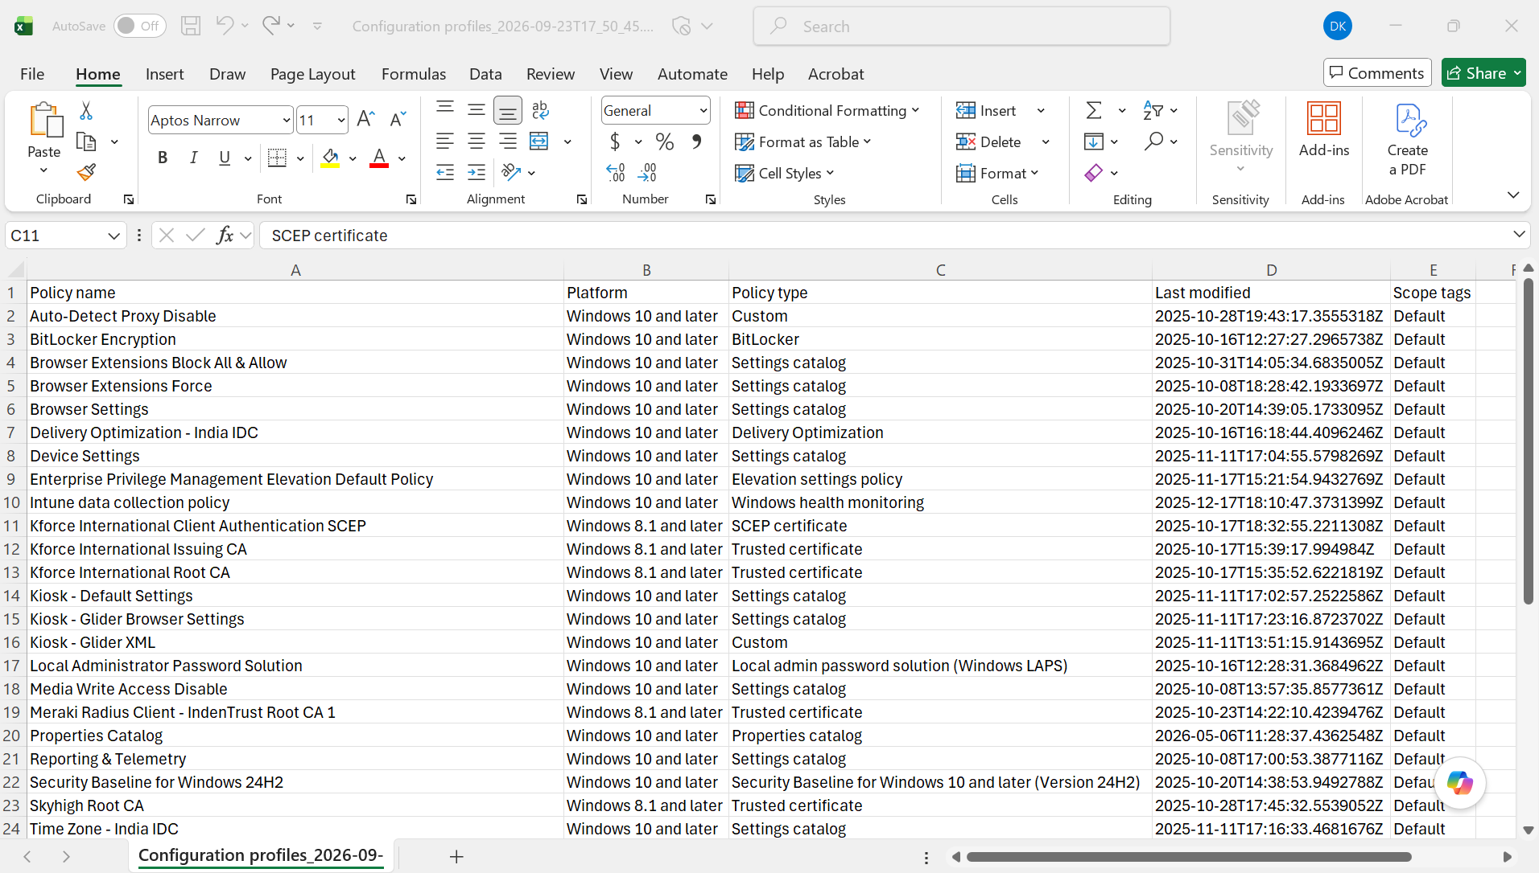
Appendix Figure 26. Additional tenant configuration reference.
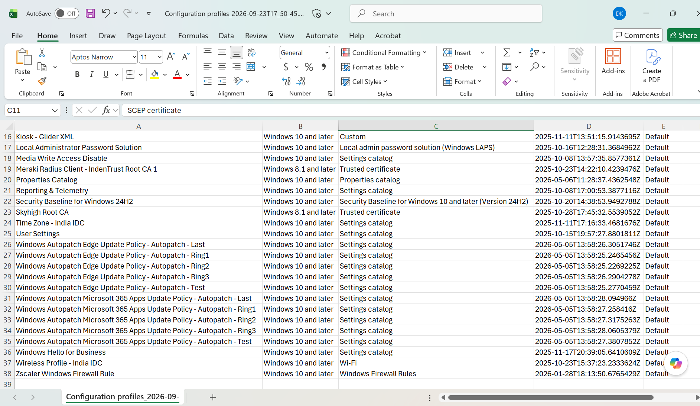
Appendix Figure 27. Additional policy reference.

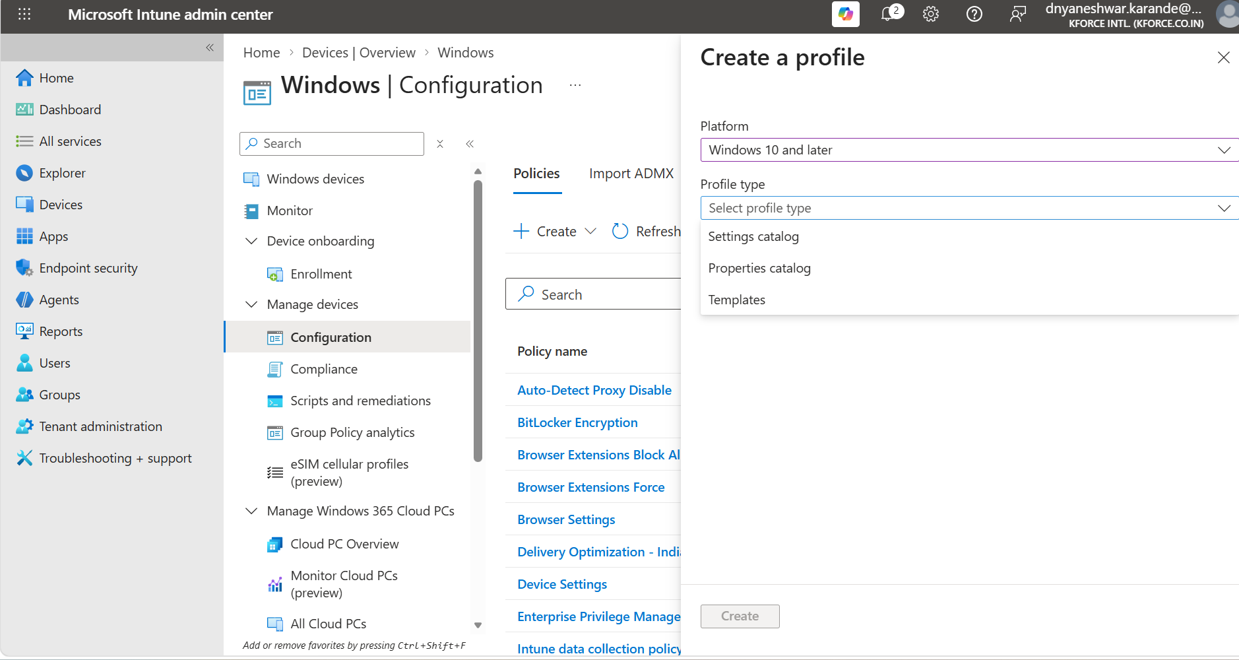
Appendix Figure 28. Additional policy reference.
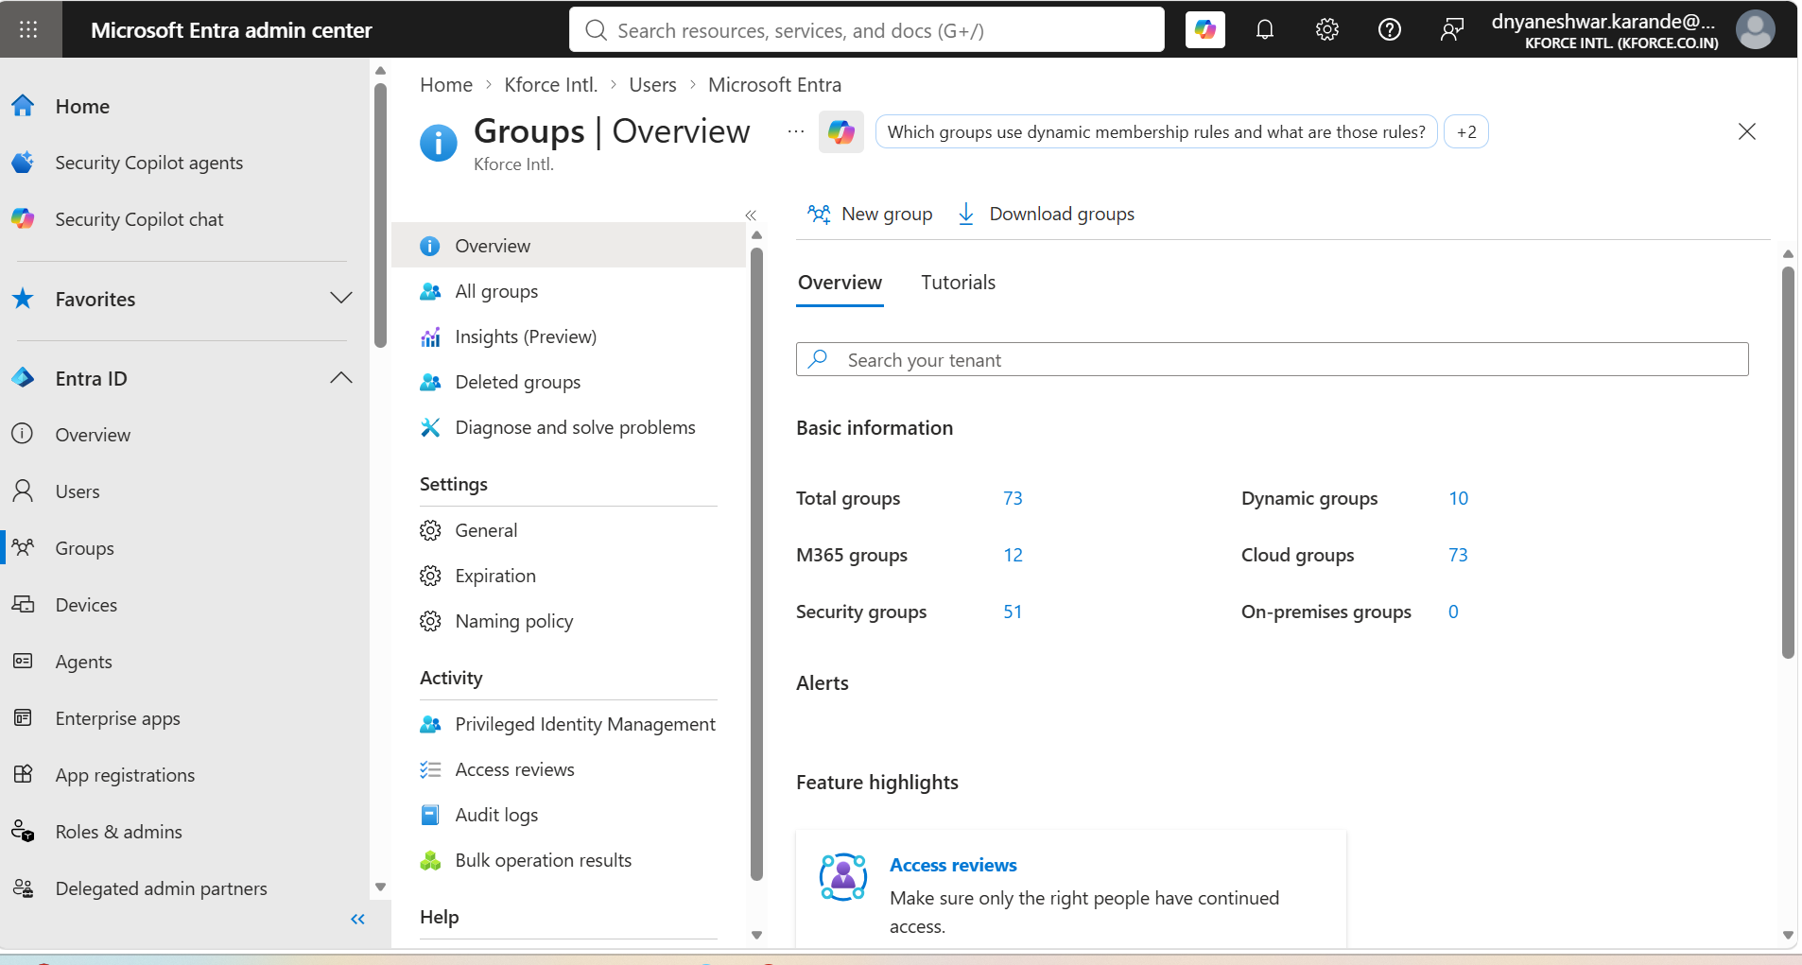
Appendix Figure 29. Additional policy reference.

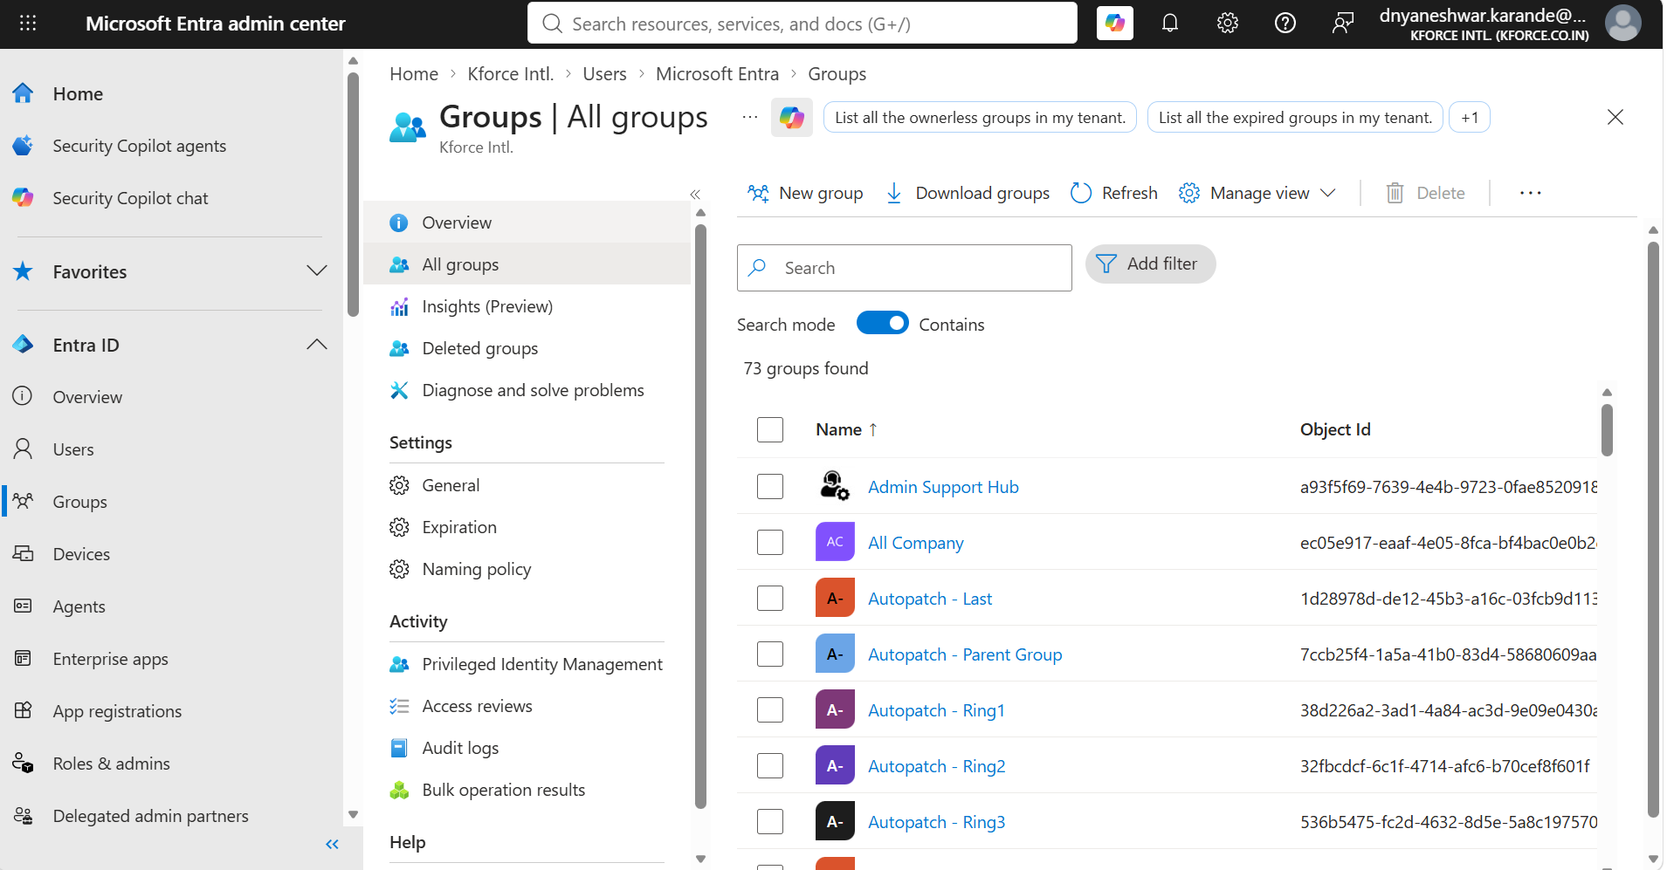
Appendix Figure 30. Additional policy reference.
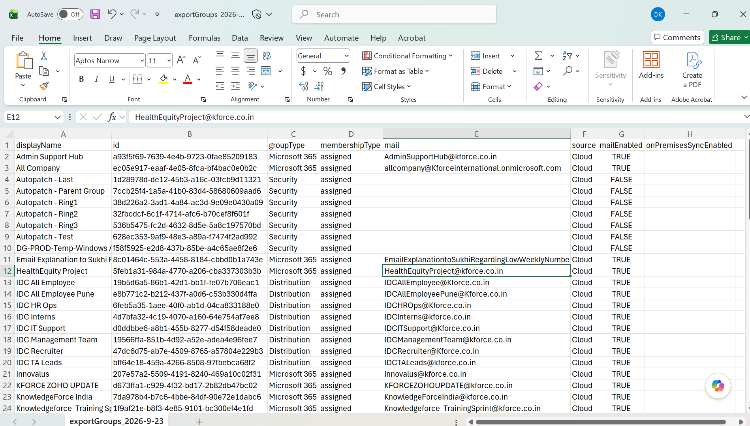
Appendix Figure 31. Additional policy reference.

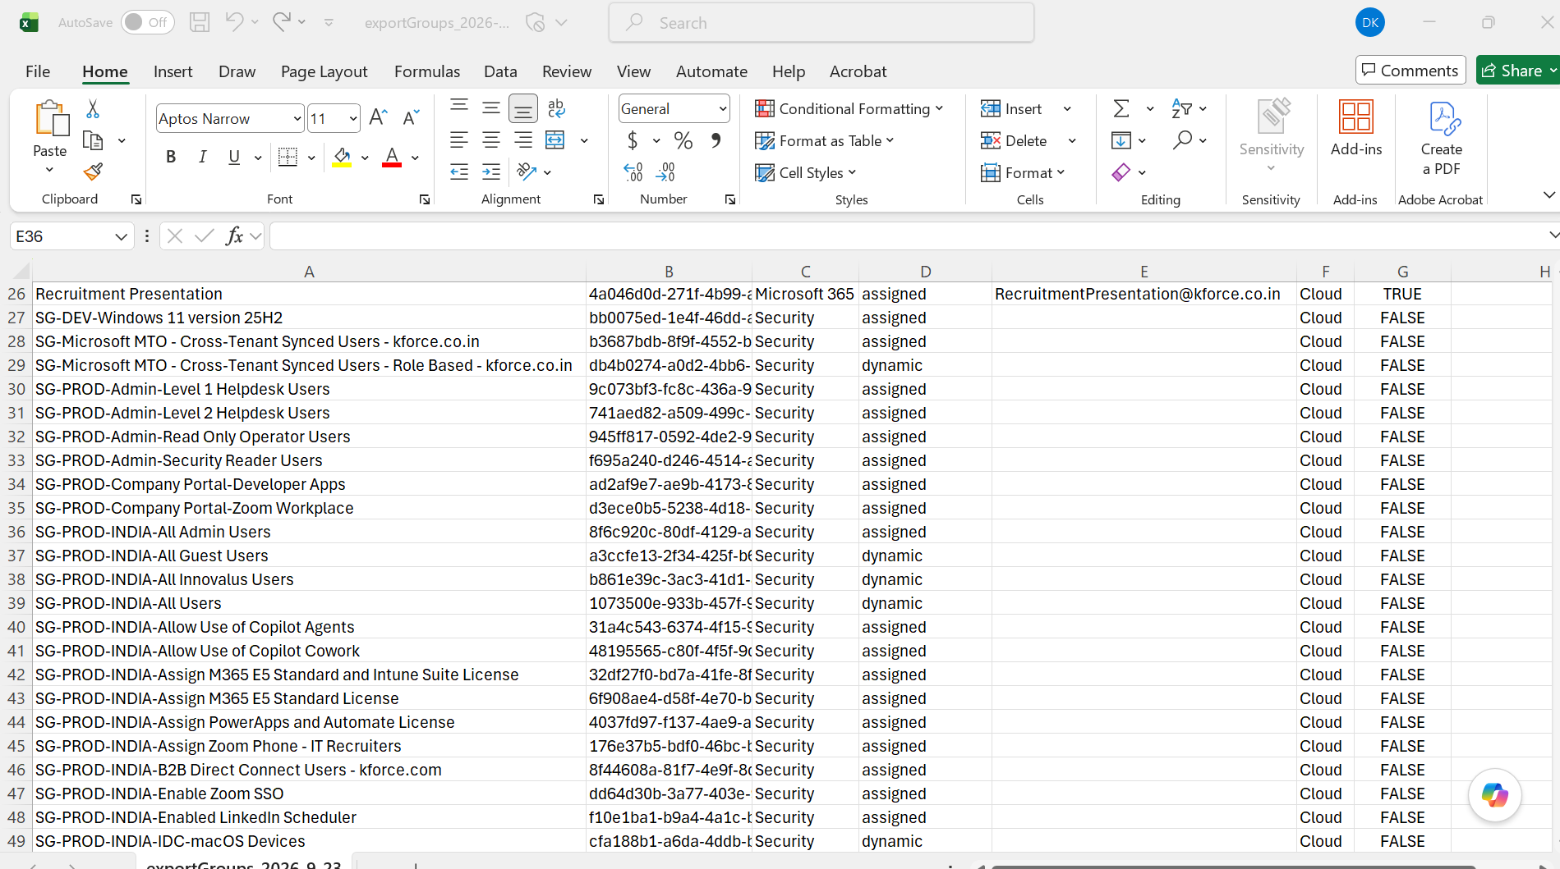
Appendix Figure 32. Additional policy reference.
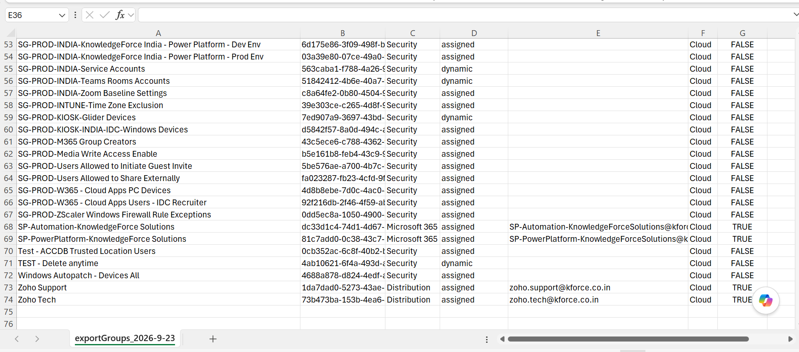
Appendix Figure 33. Additional policy reference.

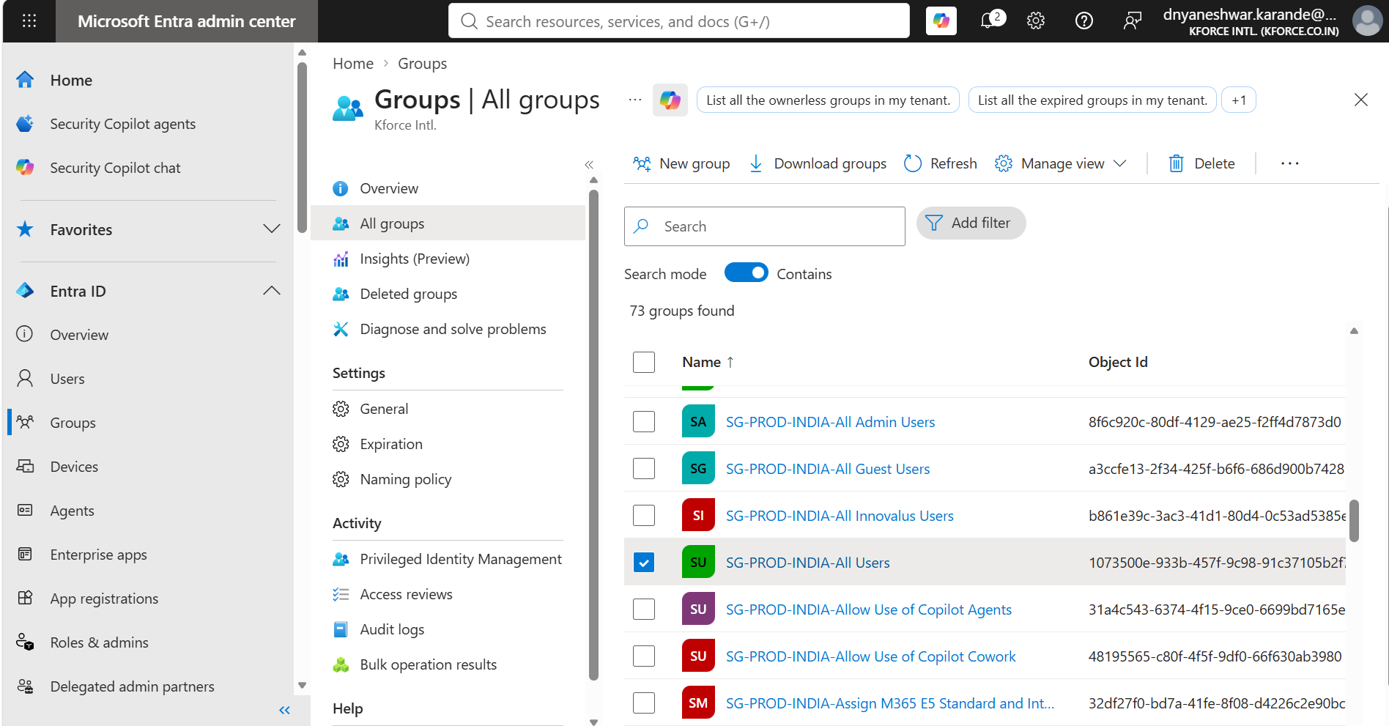
Appendix Figure 34. Additional policy reference.
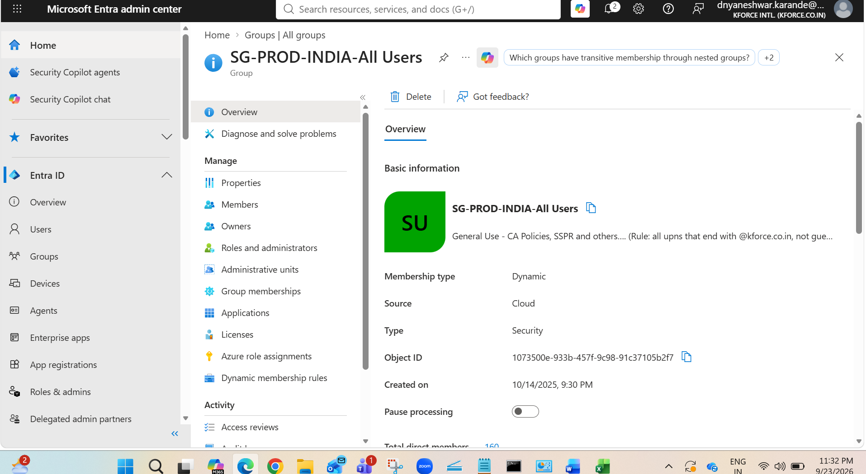
Appendix Figure 35. Additional policy reference.

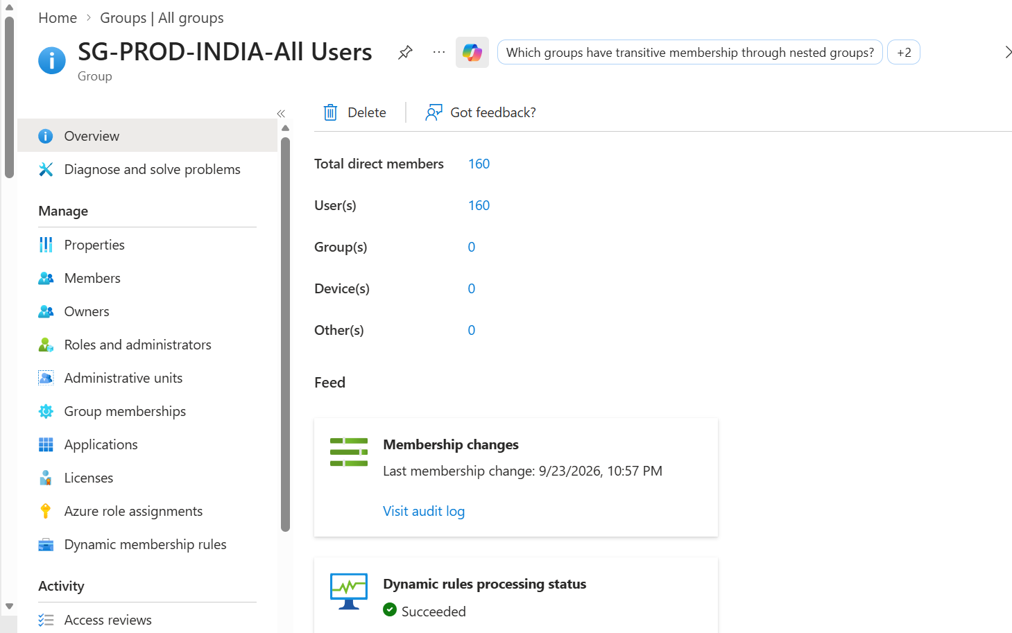
Appendix Figure 36. Profile creation or policy configuration reference.
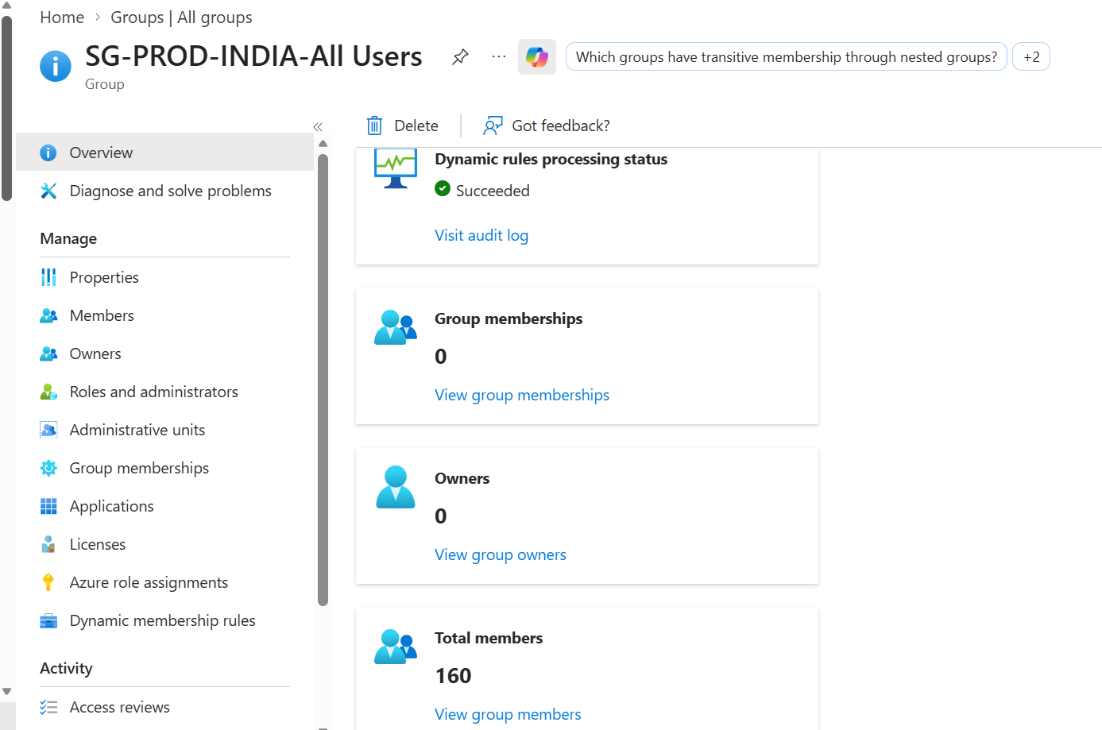
Appendix Figure 37. Profile configuration reference.

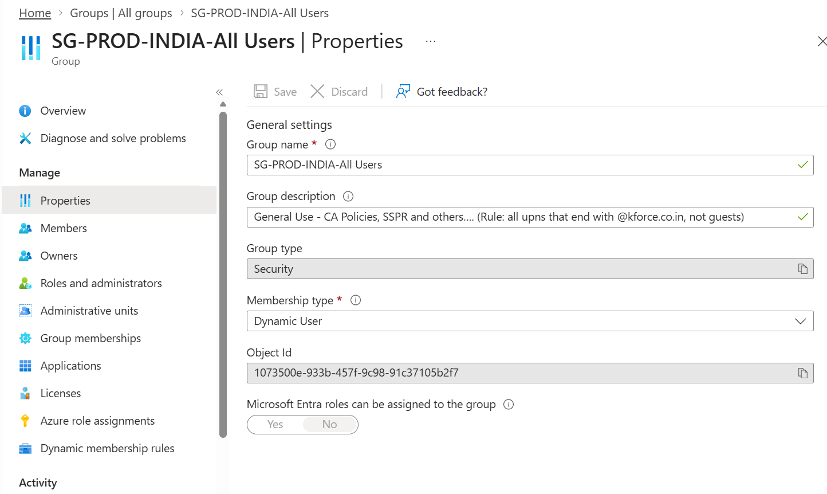
Appendix Figure 38. Profile configuration reference.
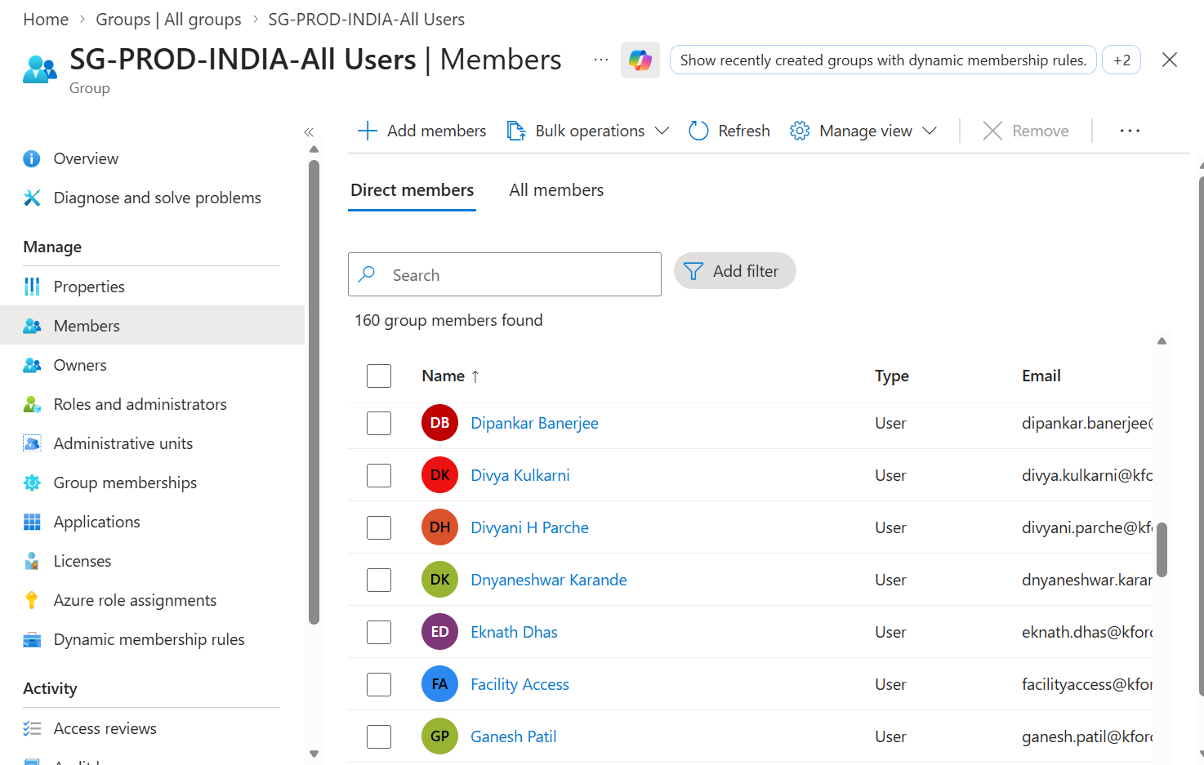
Appendix Figure 39. Profile configuration reference.

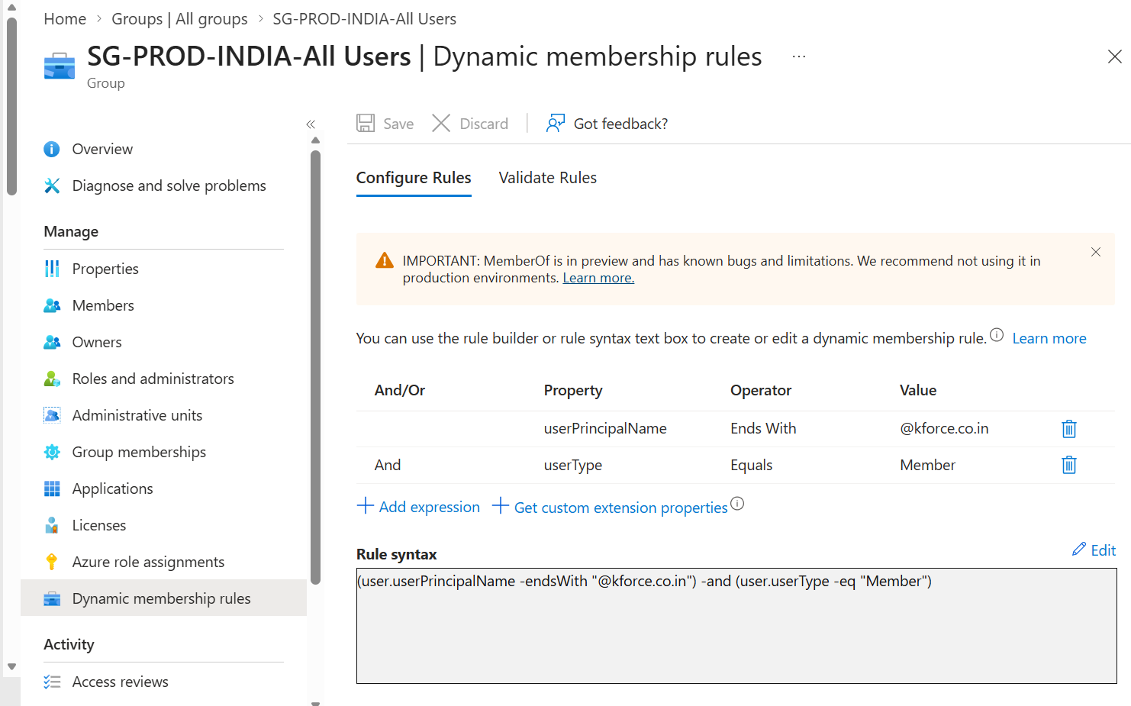
Appendix Figure 40. Profile configuration reference.
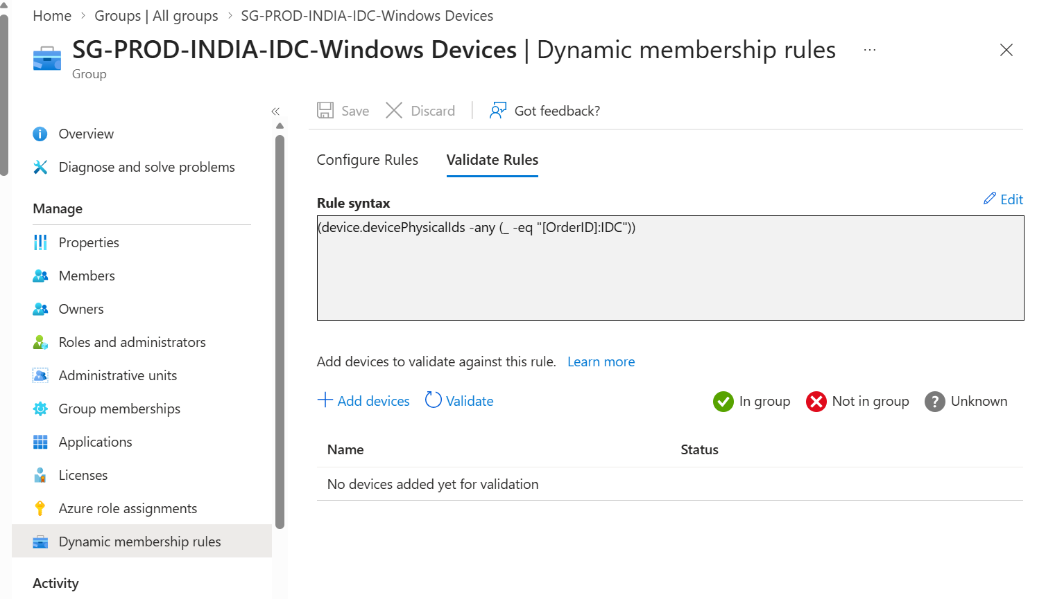
Appendix Figure 41. Profile configuration reference.

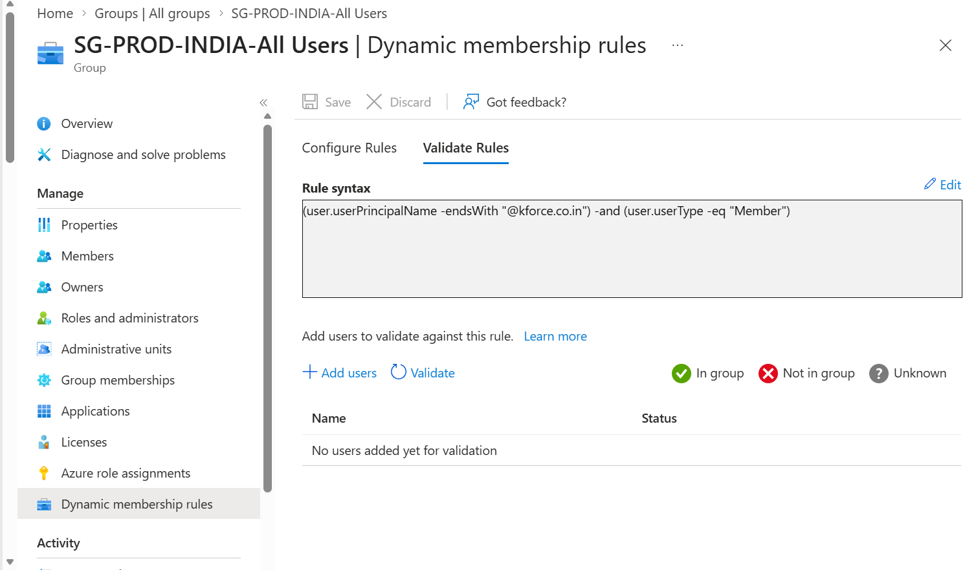
Appendix Figure 42. Profile configuration reference.
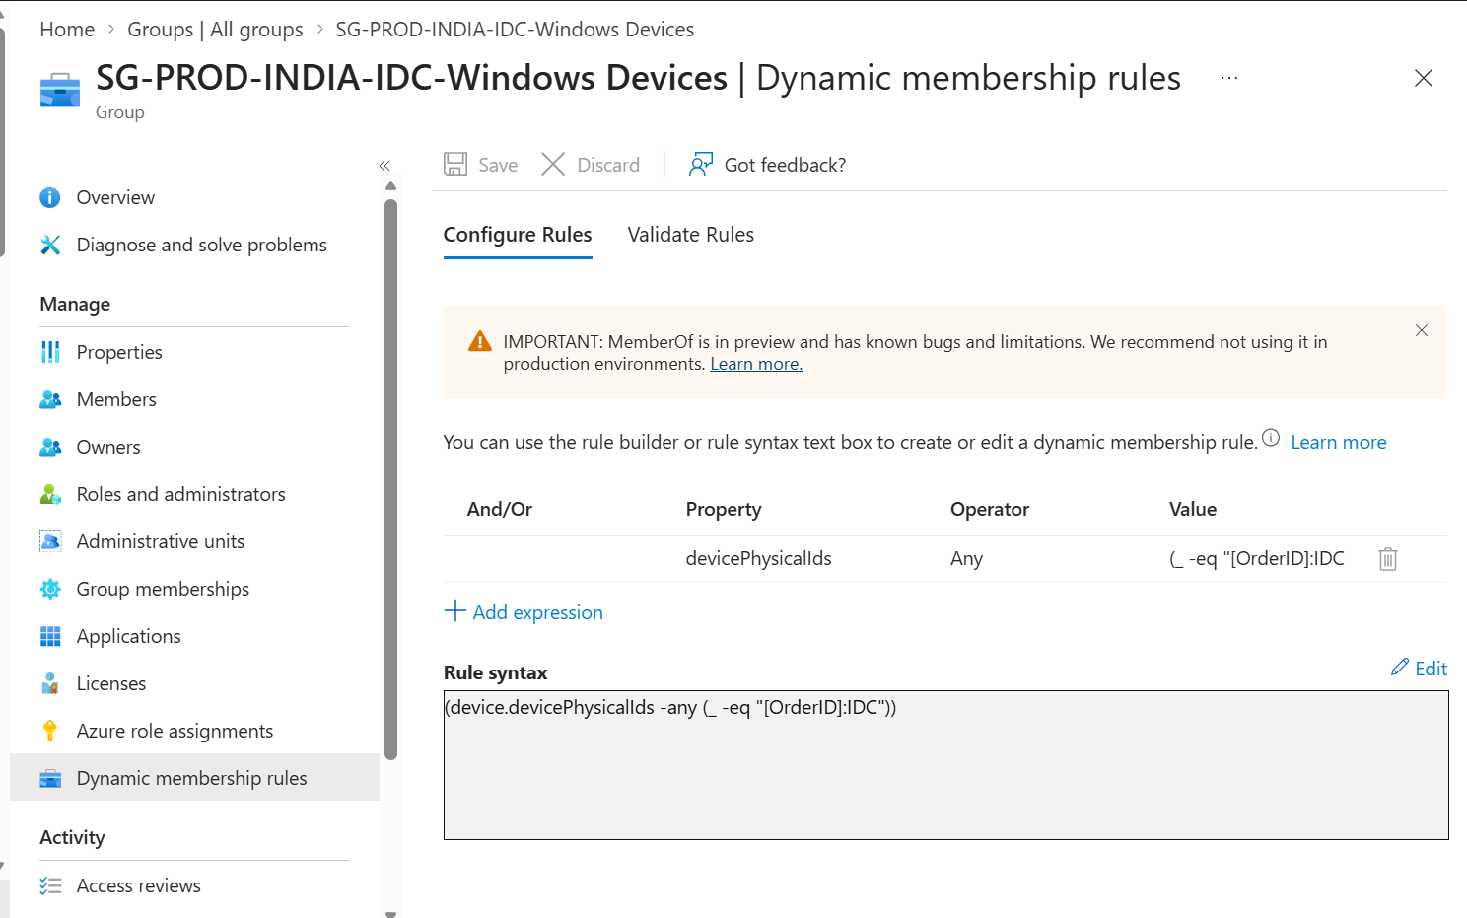
Appendix Figure 43. Profile configuration reference.

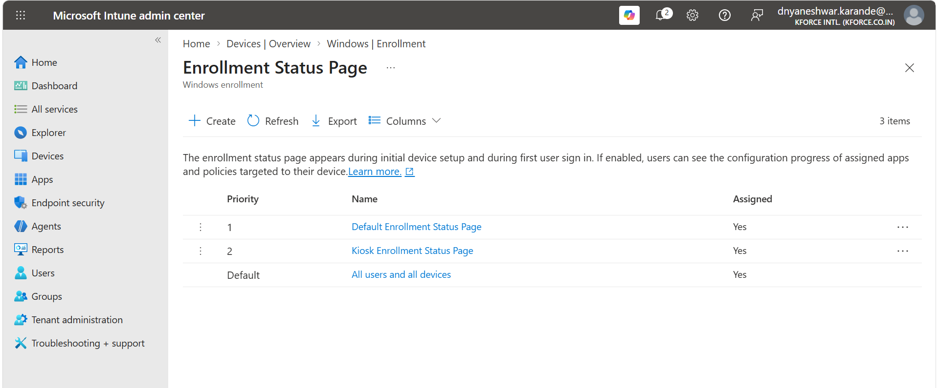
Appendix Figure 44. Windows policy configuration reference.
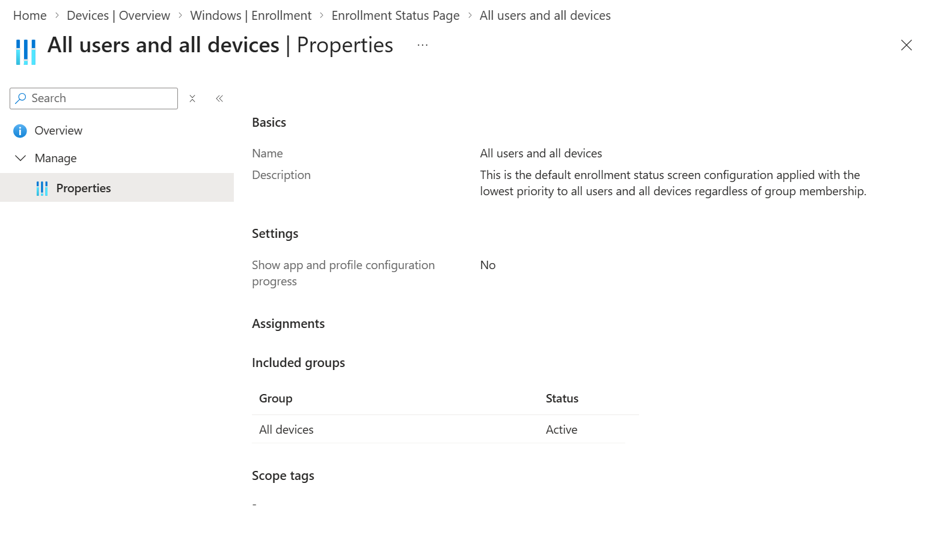
Appendix Figure 45. Configuration profile settings reference.

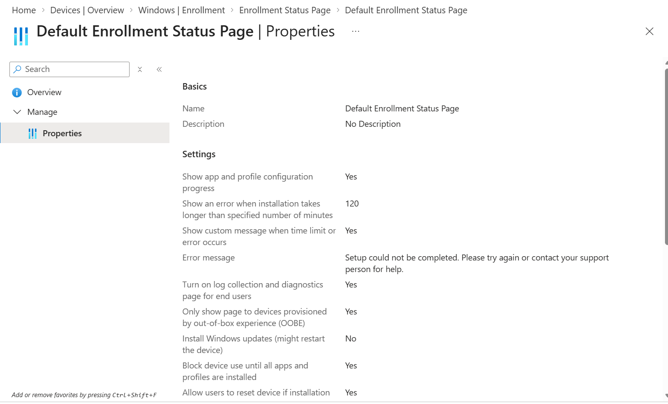
Appendix Figure 46. Configuration profile settings reference.
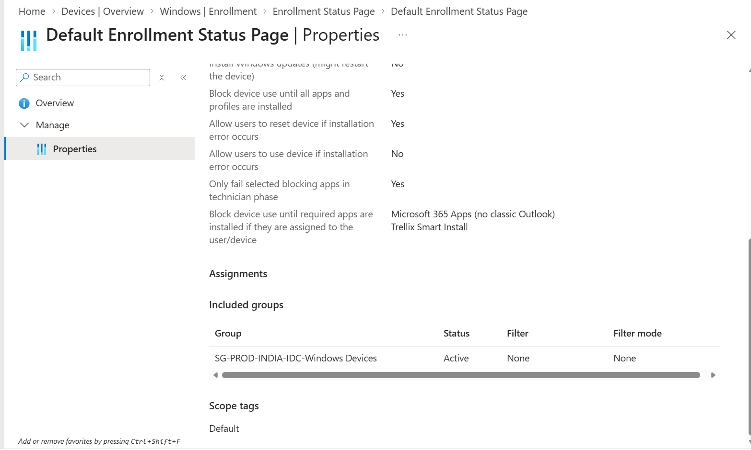
Appendix Figure 47. Configuration profile settings reference.

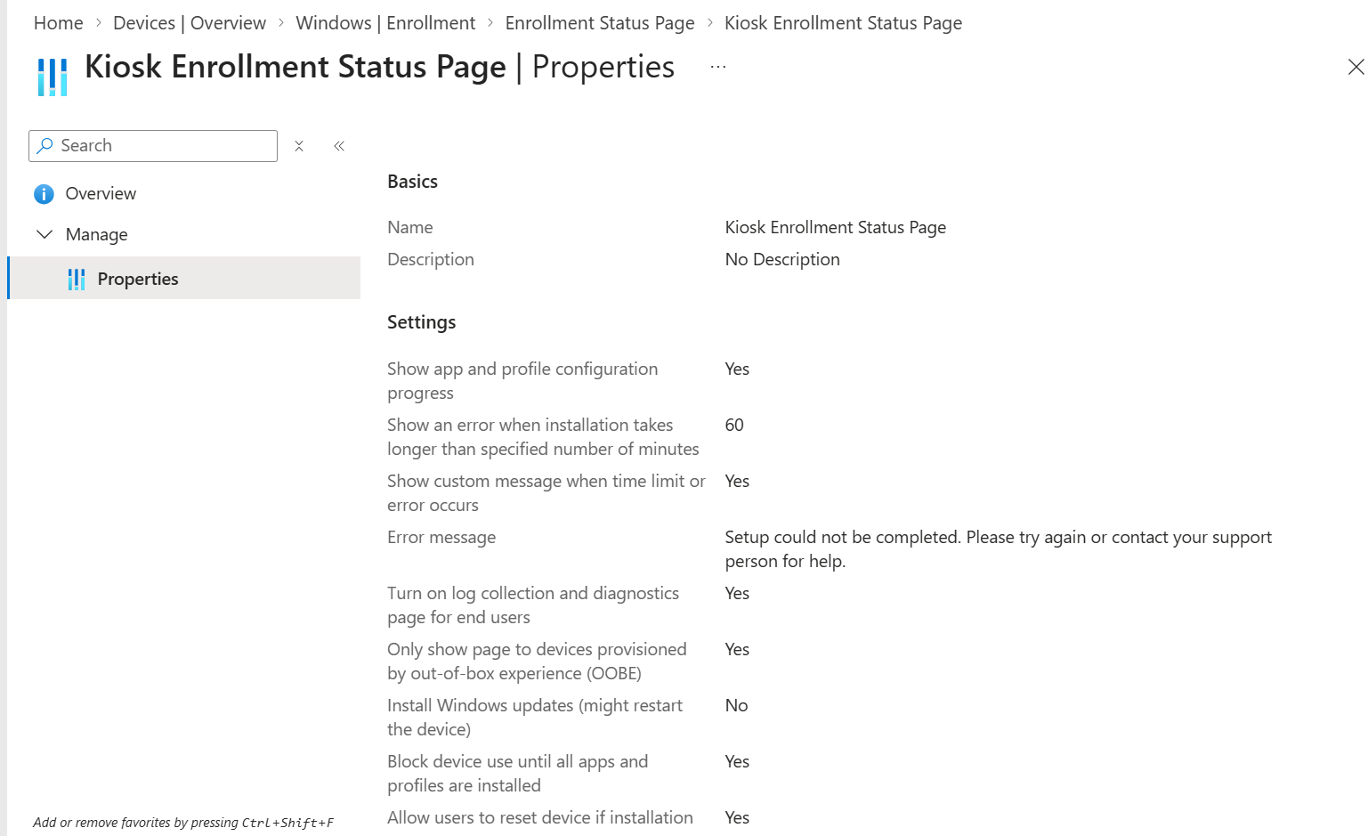
Appendix Figure 48. Configuration profile settings reference.
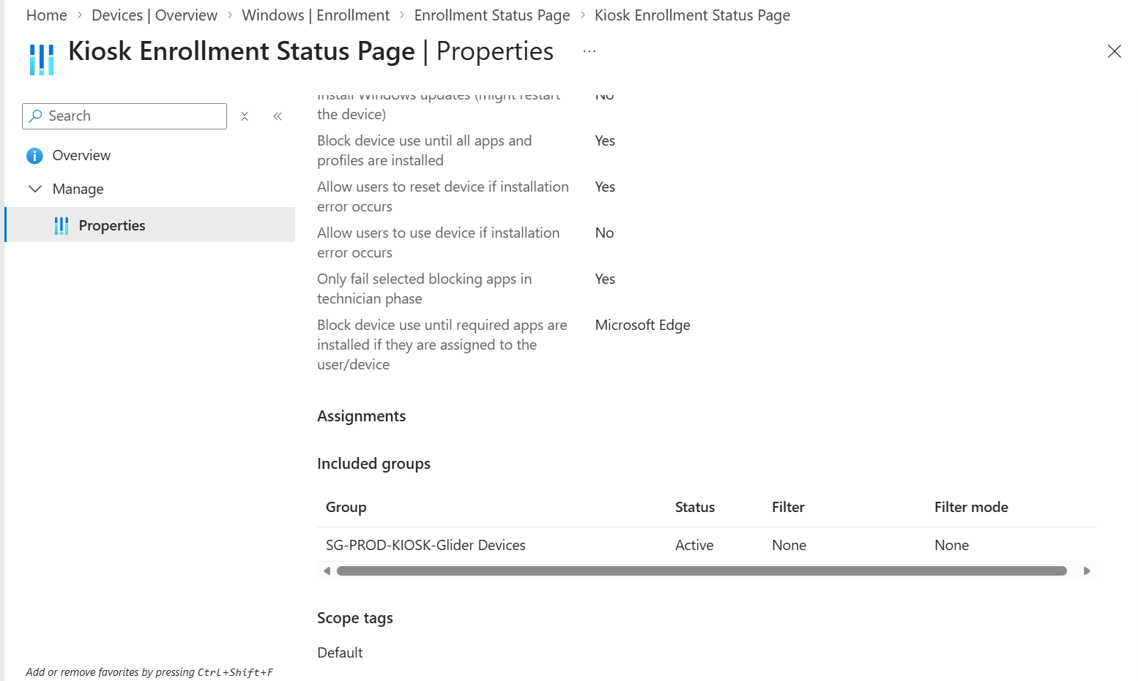
Appendix Figure 49. Configuration profile settings reference.

25. Official References and Review Triggers
- Microsoft Learn: Windows Autopilot documentation hub - https://learn.microsoft.com/autopilot/
- Microsoft Learn: Manually register devices with Windows Autopilot - https://learn.microsoft.com/autopilot/add-devices
- Microsoft Learn: Windows Autopilot deployment profiles - https://learn.microsoft.com/autopilot/profiles
- Microsoft Learn: Enrollment Status Page - https://learn.microsoft.com/mem/intune/enrollment/windows-enrollment-status
- Microsoft Learn: Windows Autopilot troubleshooting - https://learn.microsoft.com/autopilot/troubleshooting-faq
- Microsoft Learn: Windows Autopilot requirements - https://learn.microsoft.com/autopilot/requirements
Review triggers
Review this SOP after Intune portal changes, Windows Autopilot service changes, new Windows releases, licensing/RBAC changes, networking changes, security baseline changes, app lifecycle changes, or a significant deployment incident.

